25cs063
WDF-PR6

JSON Files — events.json
- JSON data displayed

Code:
Events.json

[
{
"id": 1,
"title": "Hackathon 2026",
"date": "2026-08-10",
"venue": "Computer Lab",
"category": "Technical",
"description": "A coding hackathon where students develop innovative solutions."
},
{
"id": 2,
"title": "Sports Day",
"date": "2026-09-20",
"venue": "College Ground",
"category": "Sports",
"description": "Annual sports activities including cricket, football and athletics."
},
{
"id": 3,
"title": "Cultural Fest",
"date": "2026-10-15",
"venue": "Auditorium",
"category": "Cultural",
"description": "A cultural celebration featuring music, dance and drama."
},
{
"id": 4,
"title": "Web Development Workshop",
"date": "2026-10-25",
"venue": "Seminar Hall",
"category": "Workshop",
"description": "Hands-on workshop covering HTML, CSS and JavaScript."
},
{
"id": 5,
"title": "Coding Competition",
"date": "2026-11-05",
"venue": "Programming Lab",
"category": "Technical",
"description": "Competitive programming event for students."
},
{
"id": 6,
"title": "Industrial Visit",
"date": "2026-11-12",
"venue": "Ahmedabad",
"category": "Industrial Visit",
"description": "Educational industrial visit to understand real-world technology."
},
{
"id": 7,
"title": "Guest Lecture on AI",
"date": "2026-11-20",
"venue": "Conference Hall",
"category": "Guest Lecture",
"description": "Expert lecture introducing students to Artificial Intelligence."
},
{
"id": 8,
"title": "Career Guidance Program",
"date": "2026-11-28",
"venue": "Seminar Hall",
"category": "Career",
"description": "Career guidance session covering higher studies and job opportunities."
},
{
"id": 9,
"title": "Java Programming Workshop",
"date": "2026-12-03",
"venue": "Computer Lab",
"category": "Workshop",
"description": "Practical workshop on Java programming and object-oriented concepts."
},
{
"id": 10,
"title": "Quiz Competition",
"date": "2026-12-10",
"venue": "Classroom Block",
"category": "Academic",
"description": "General knowledge and technical quiz competition."
},
{
"id": 11,
"title": "Photography Contest",
"date": "2026-12-15",
"venue": "College Campus",
"category": "Cultural",
"description": "Photography competition showcasing creativity and campus life."
},
{
"id": 12,
"title": "Football Tournament",
"date": "2026-12-20",
"venue": "College Ground",
"category": "Sports",
"description": "Inter-department football tournament for students."
},
{
"id": 13,
"title": "Cyber Security Seminar",
"date": "2027-01-08",
"venue": "Conference Hall",
"category": "Technical",
"description": "Seminar on cyber security, online safety and ethical hacking."
},
{
"id": 14,
"title": "Resume Building Workshop",
"date": "2027-01-15",
"venue": "Seminar Hall",
"category": "Career",
"description": "Workshop helping students create professional resumes."
},
{
"id": 15,
"title": "Annual College Day",
"date": "2027-01-25",
"venue": "Main Auditorium",
"category": "Cultural",
"description": "Annual college celebration with student performances and awards."
}
]

ScreenShort:
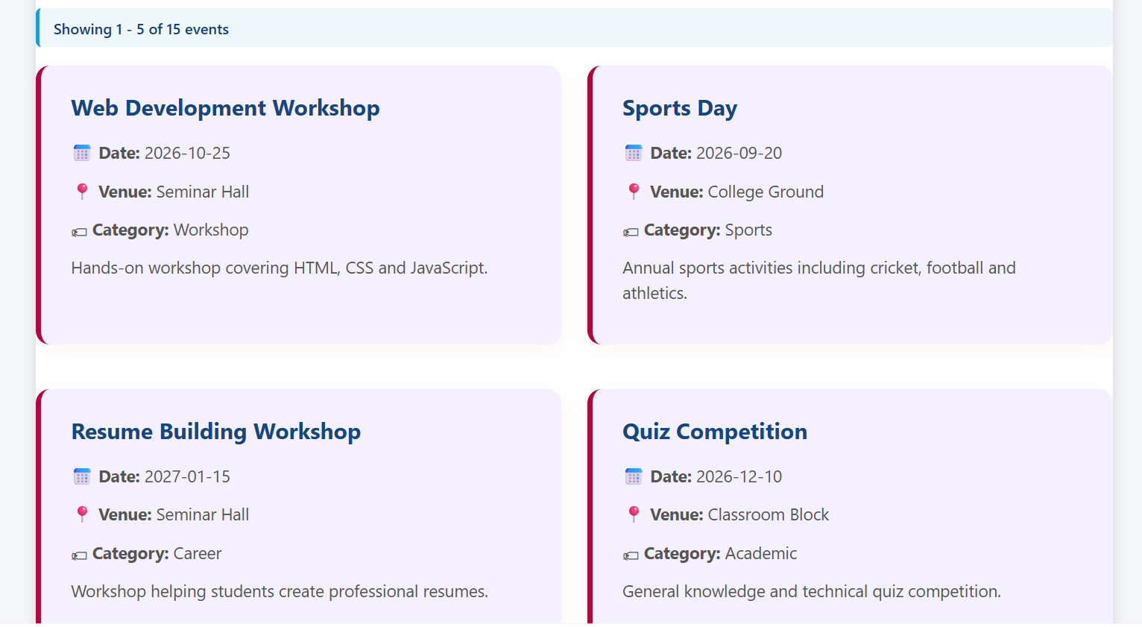

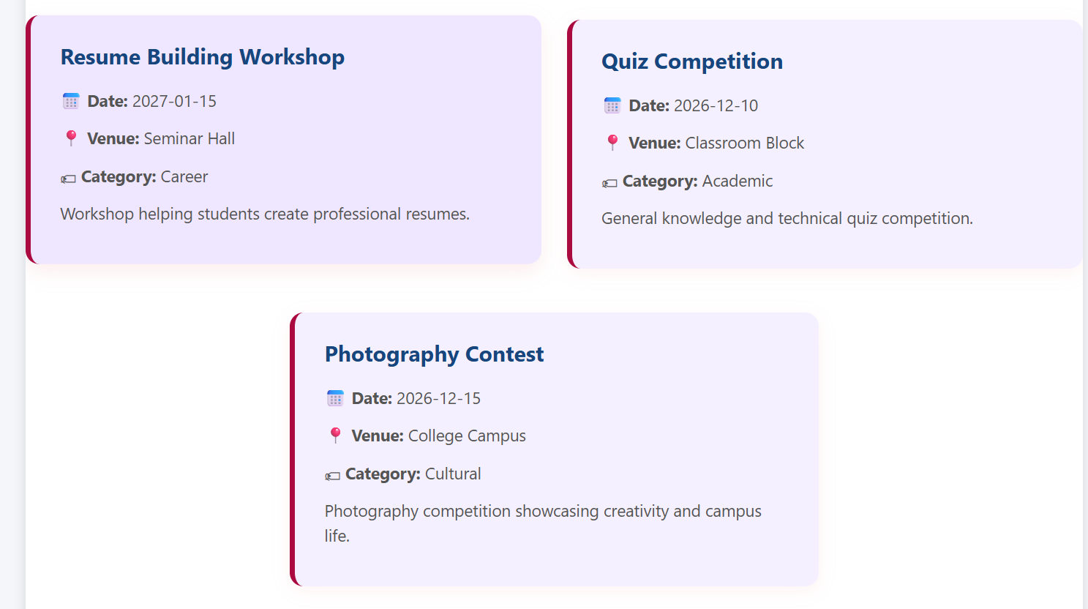

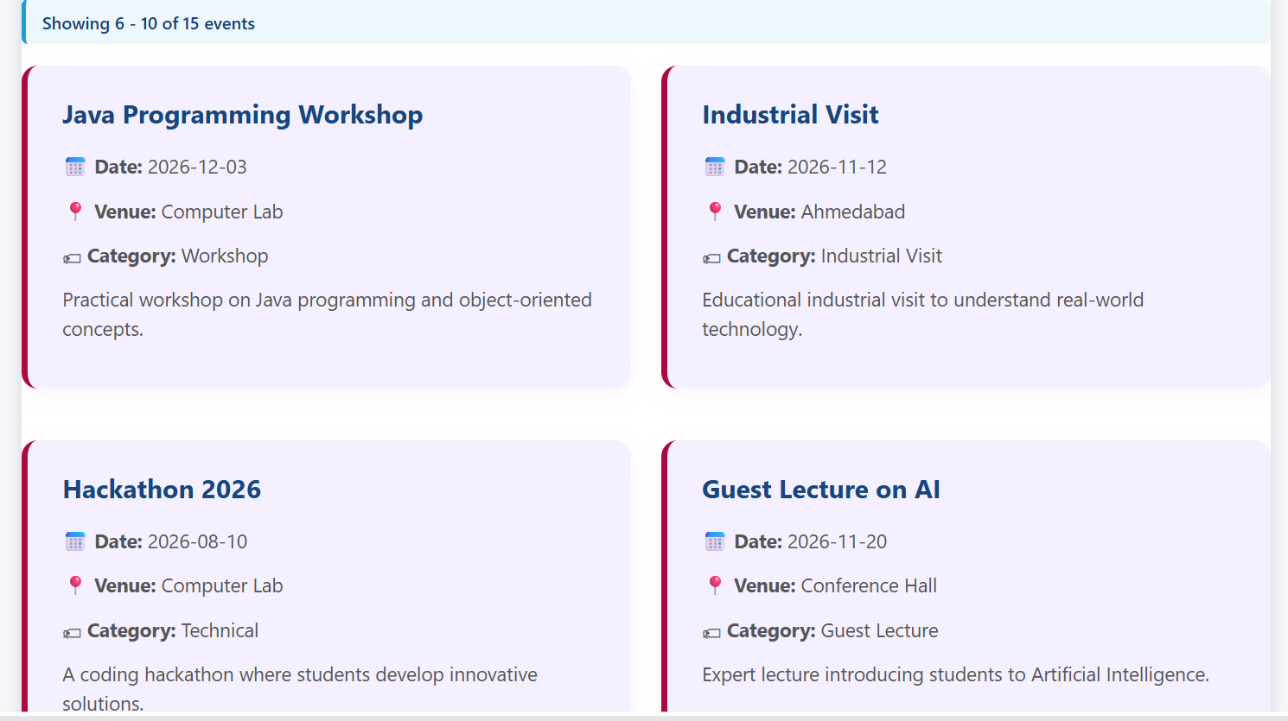

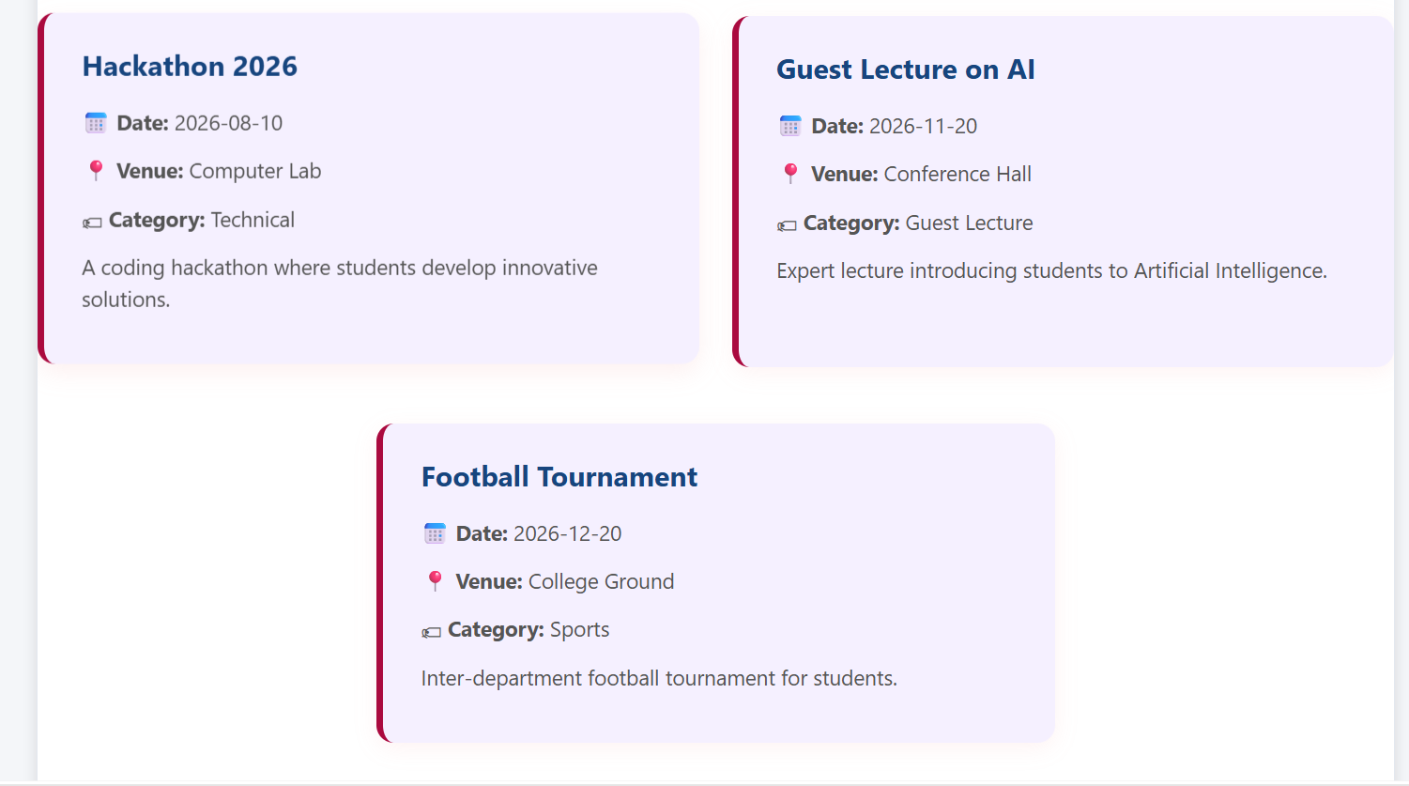

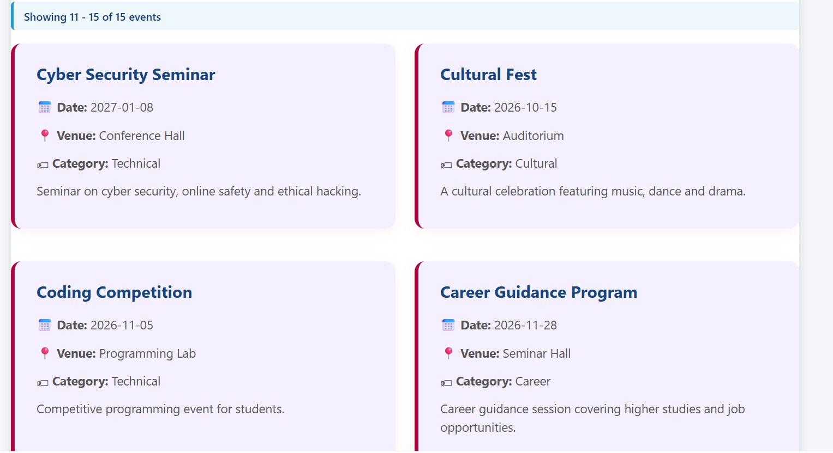
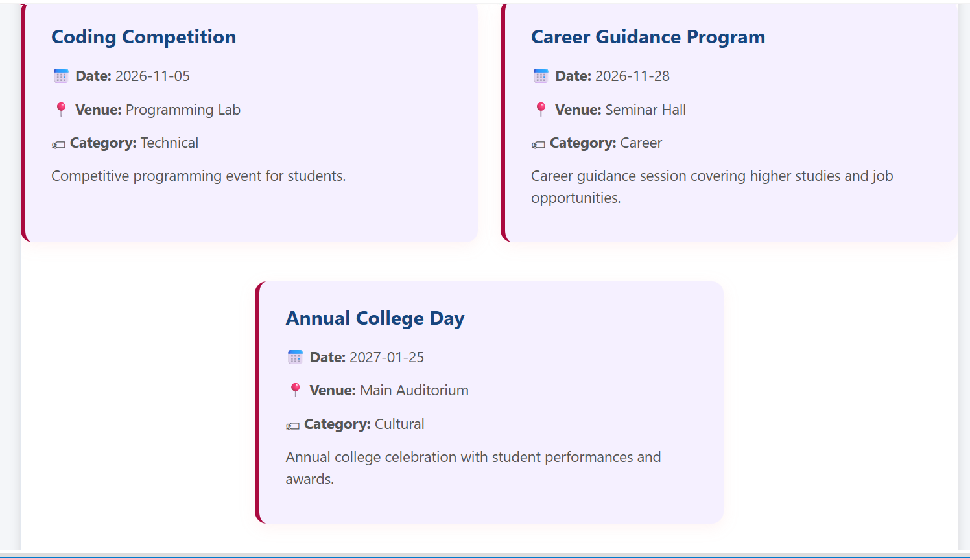

Fetch API

Code:
fetch("events.json")
.then(function (response) {

if (!response.ok) {
throw new Error(
"Unable to load events.json"
);
}

return response.json();
})

.then(function (data) {

allEvents = data;
filteredEvents = [...allEvents];

if (loadingMessage) {
loadingMessage.style.display = "none";
}

createCategories();
displayEvents();
})

.catch(function (error) {

console.error(
"Fetch Error:",
error
);

if (loadingMessage) {
loadingMessage.style.display = "none";
}

if (errorMessage) {
errorMessage.style.display = "block";
}
});
ScreenShort:
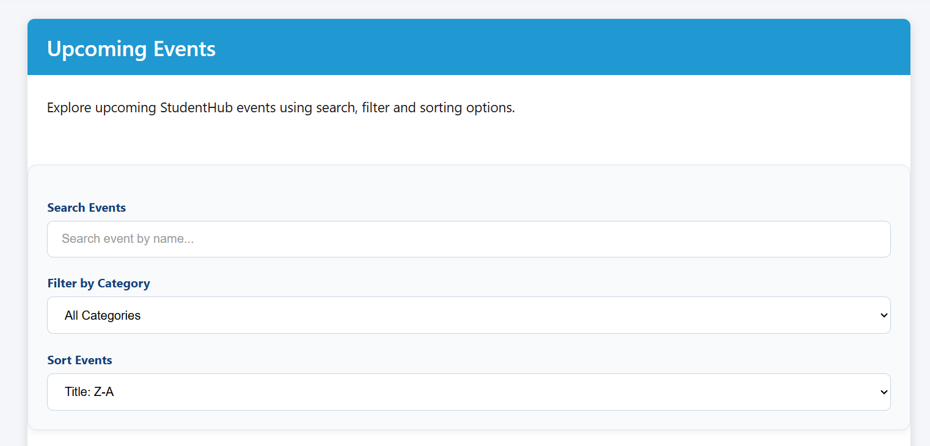

Dynamic Rendering

Code:
pageEvents.forEach(function (event) {

const card =
document.createElement("div");

card.className = "event-card";

const title =
document.createElement("h3");

title.textContent =
event.title;

const date =
document.createElement("p");

date.innerHTML =
"<strong>📅 Date:</strong> " +
event.date;

const venue =
document.createElement("p");

venue.innerHTML =
"<strong>📍 Venue:</strong> " +
event.venue;

const category =
document.createElement("p");

category.innerHTML =
"<strong>🏷 Category:</strong> " +
event.category;

const description =
document.createElement("p");

description.textContent =
event.description;

card.appendChild(title);
card.appendChild(date);
card.appendChild(venue);
card.appendChild(category);
card.appendChild(description);

eventContainer.appendChild(card);
});

ScreenShort:

Search & Filter
- Search result

Code:
if (eventSearch) {

eventSearch.addEventListener(
"input",
function () {

applyFilters();

}
);

}
const matchesSearch =
title.includes(searchText) ||
category.includes(searchText) ||
venue.includes(searchText);

ScreenShort:
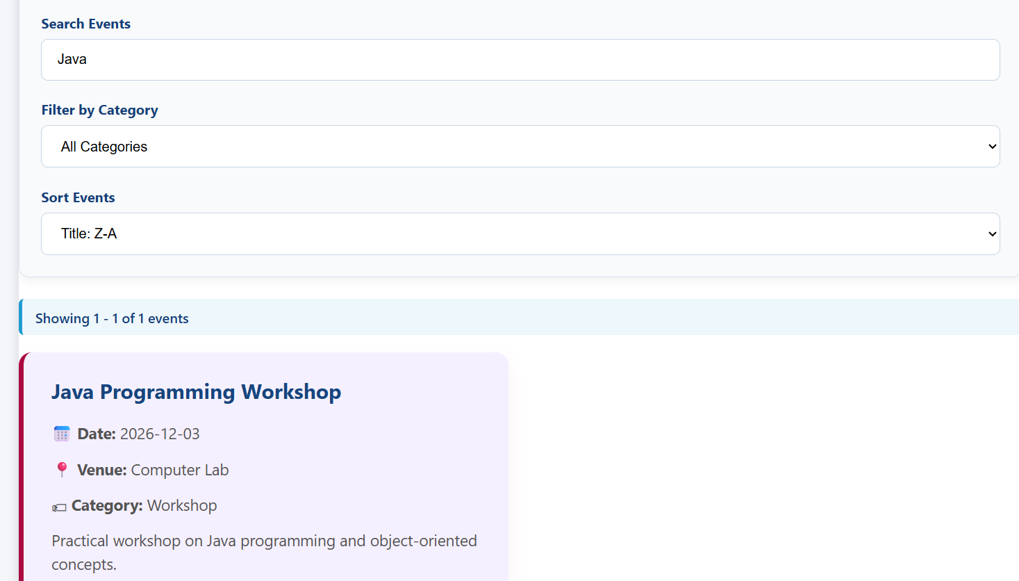

- Filter result

if (categoryFilter) {

categoryFilter.addEventListener(
"change",
function () {

applyFilters();

}
);

}

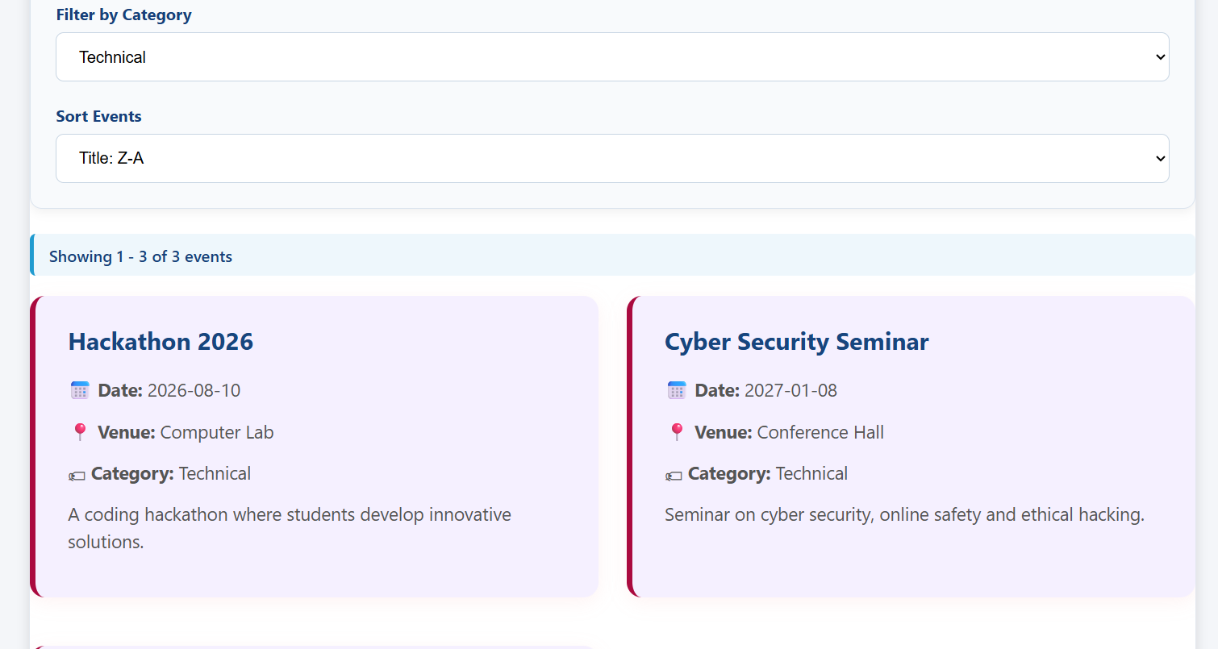

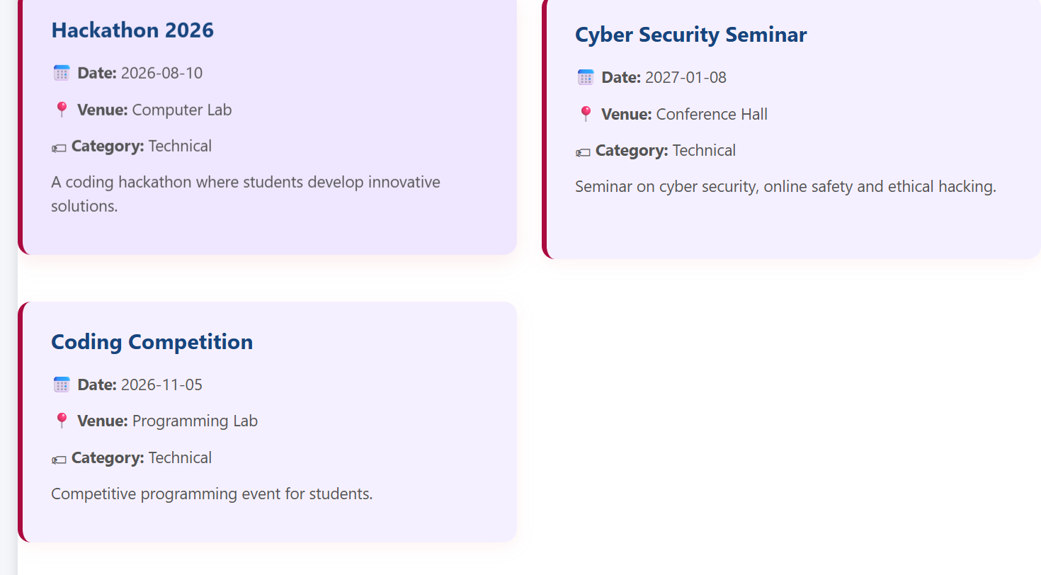
Sorting

Code:
filteredEvents.sort(
function (a, b) {

if (selectedSort === "title-asc") {

return a.title.localeCompare(
b.title
);

}

if (selectedSort === "title-desc") {

return b.title.localeCompare(
a.title
);

}

if (selectedSort === "date-desc") {

return new Date(b.date) -
new Date(a.date);

}

return new Date(a.date) -
new Date(b.date);

}
);

ScreenShort:

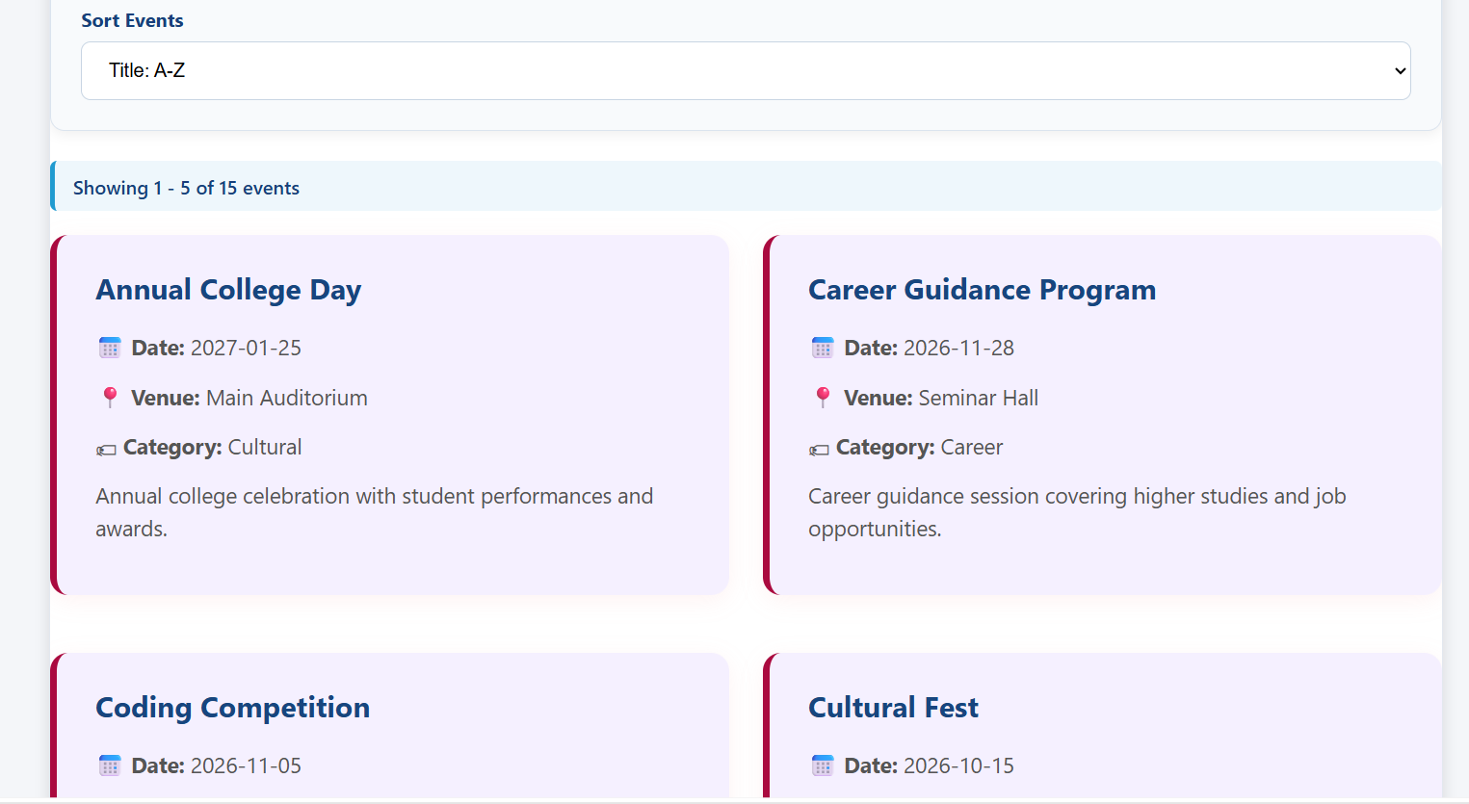

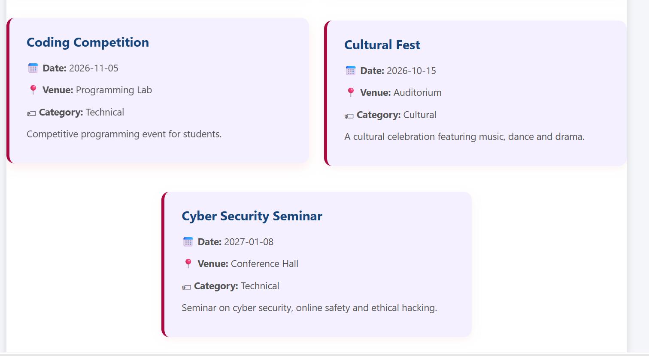

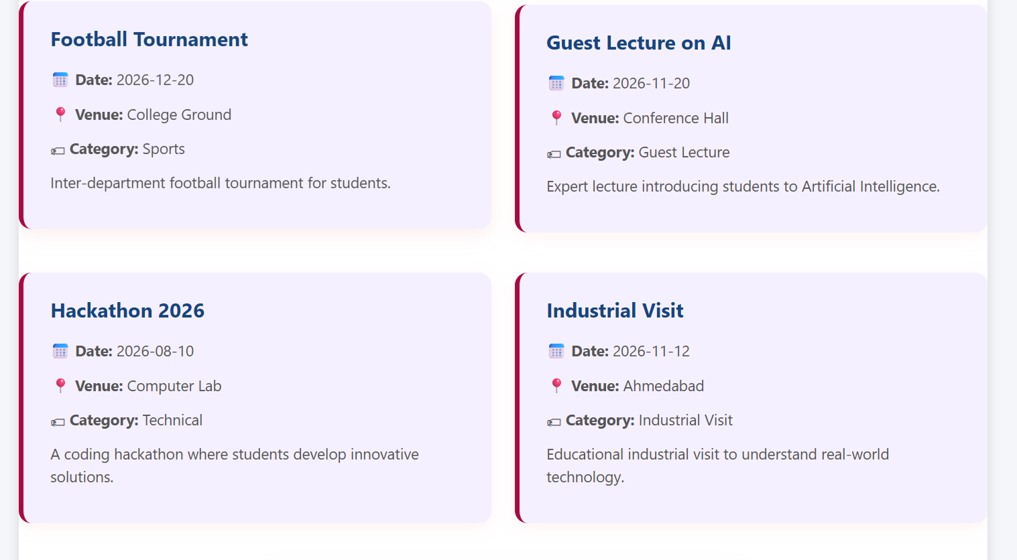
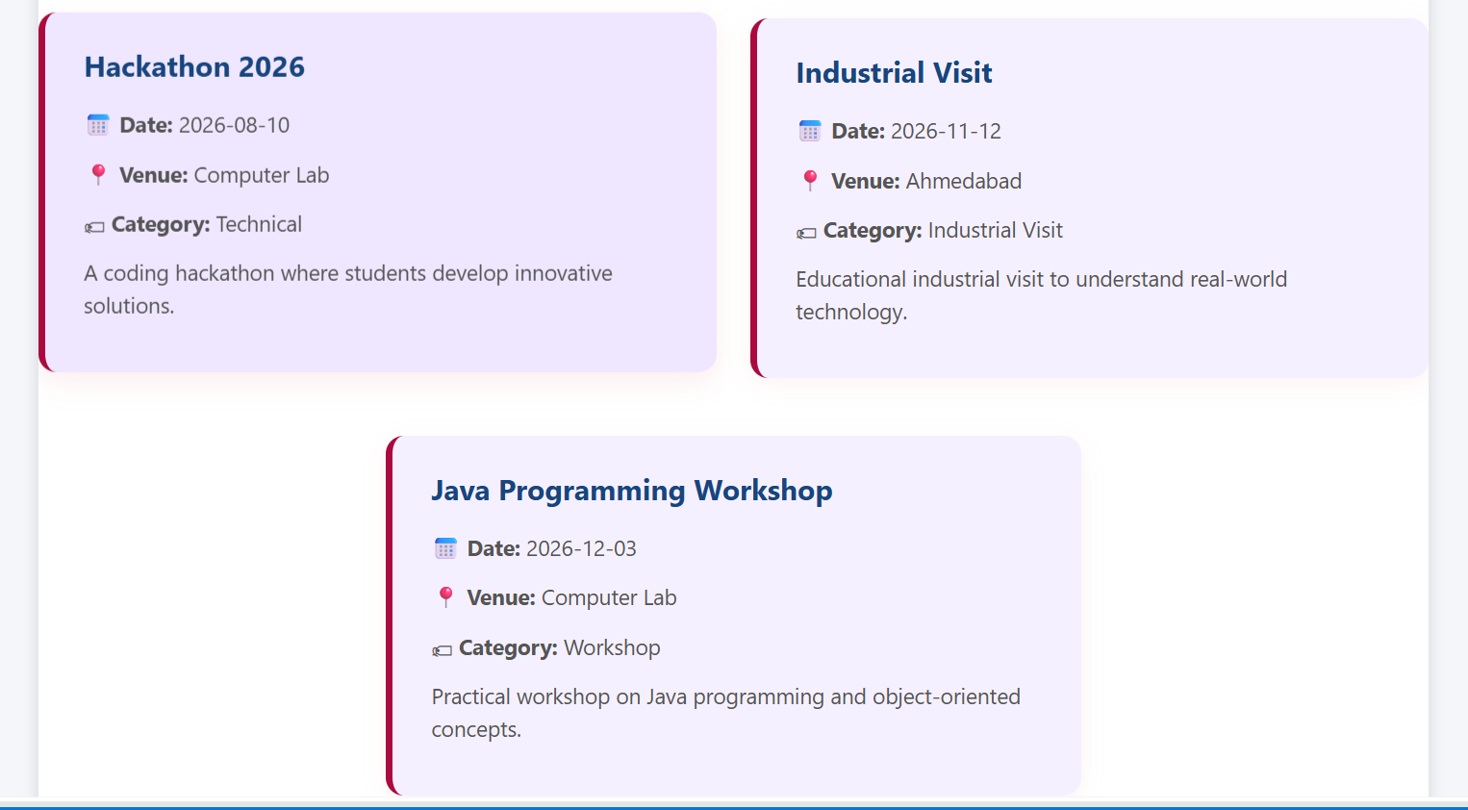

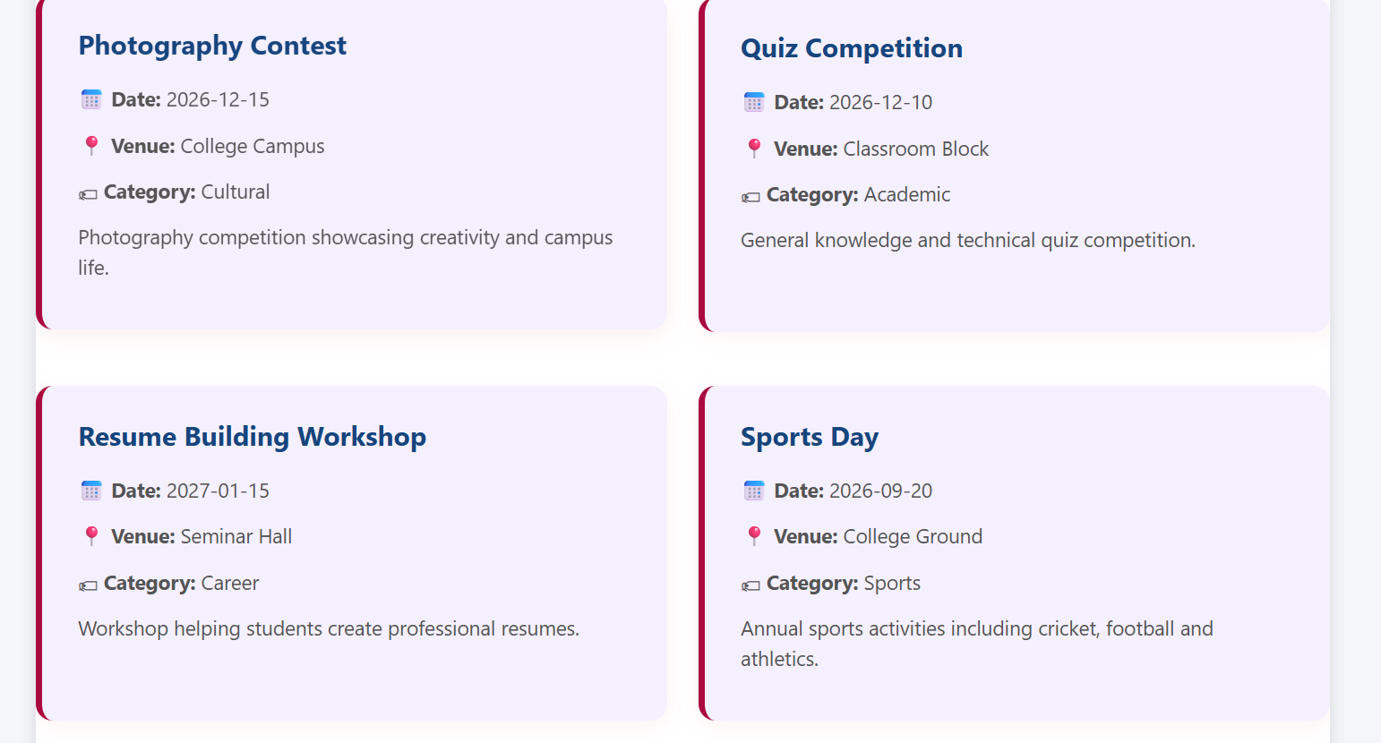

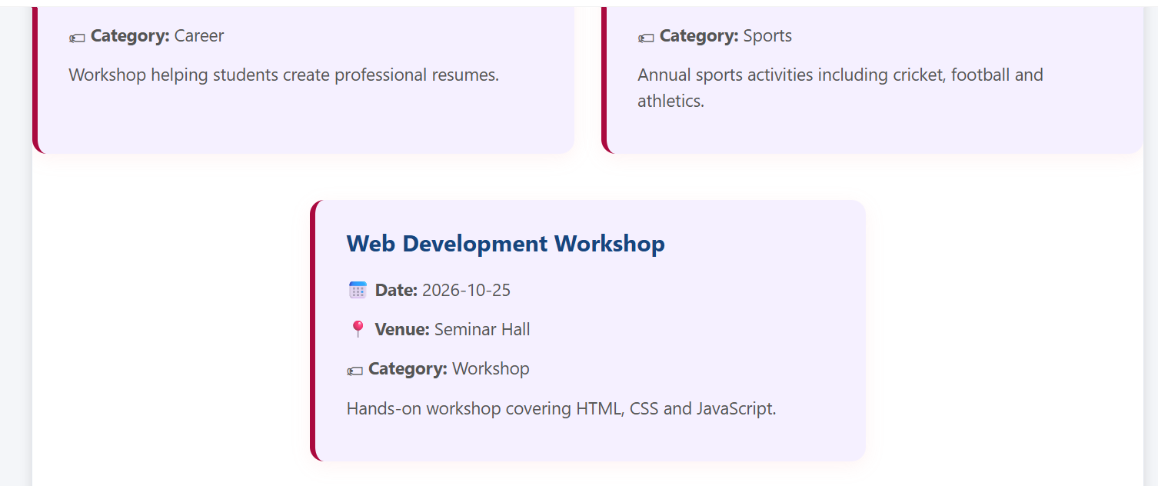

Pagination
Code:
const startIndex =
(currentPage - 1) * eventsPerPage;

const endIndex =
startIndex + eventsPerPage;

const pageEvents =
filteredEvents.slice(
startIndex,
endIndex
);
const totalPages =
Math.ceil(
filteredEvents.length /
eventsPerPage
);

for (
let page = 1;
page <= totalPages;
page++
) {

const pageButton =
document.createElement("button");

pageButton.innerText = page;

...

pageButton.addEventListener(
"click",
function () {

currentPage = page;
displayEvents();

}
);

}
ScreenShort:
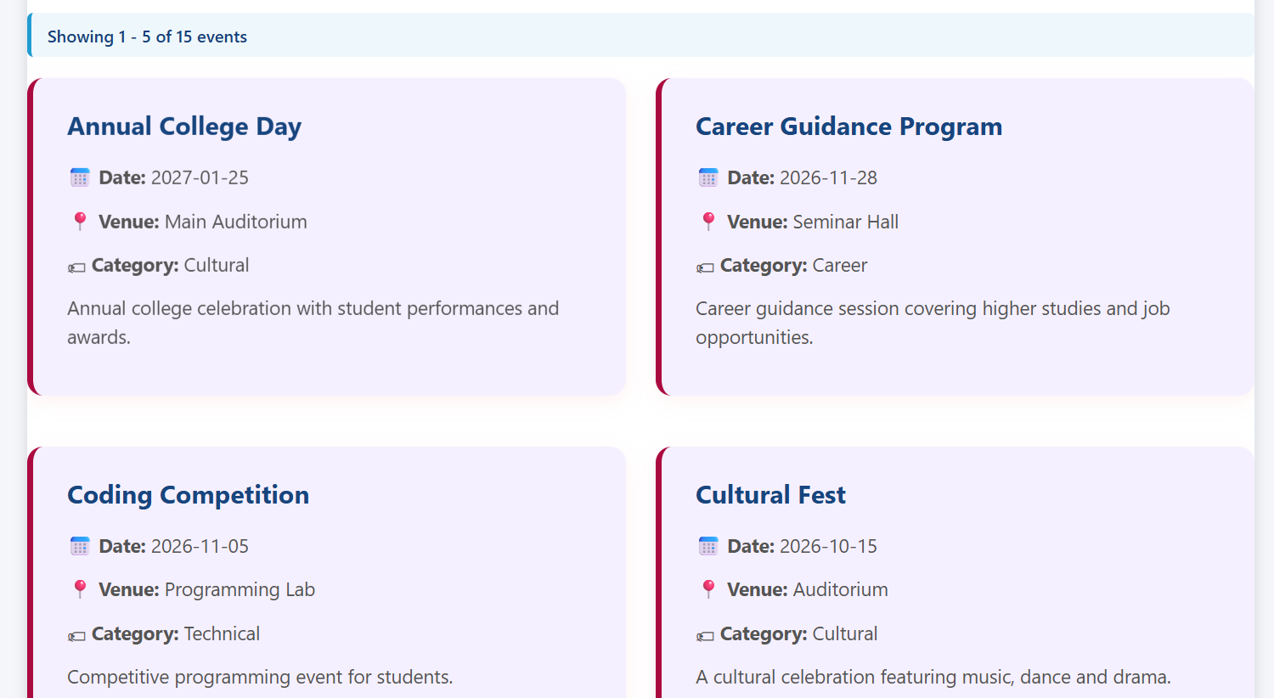

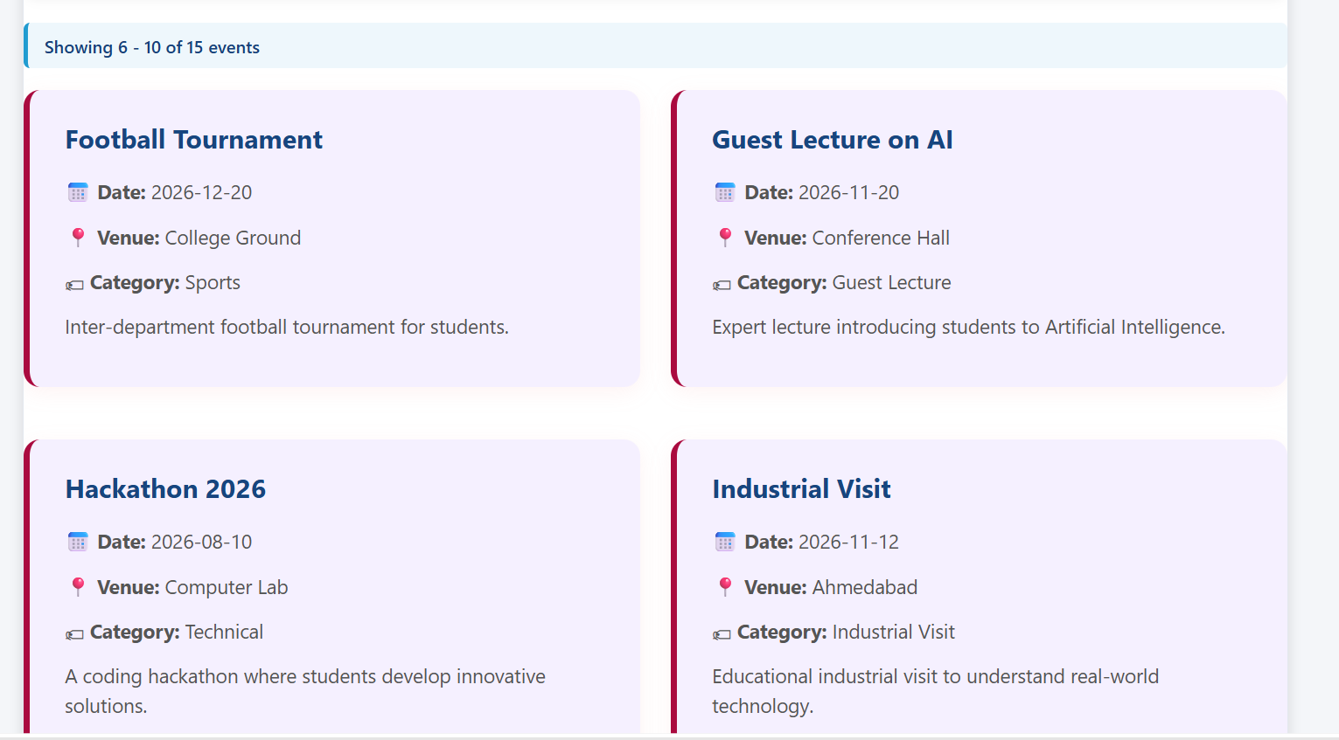

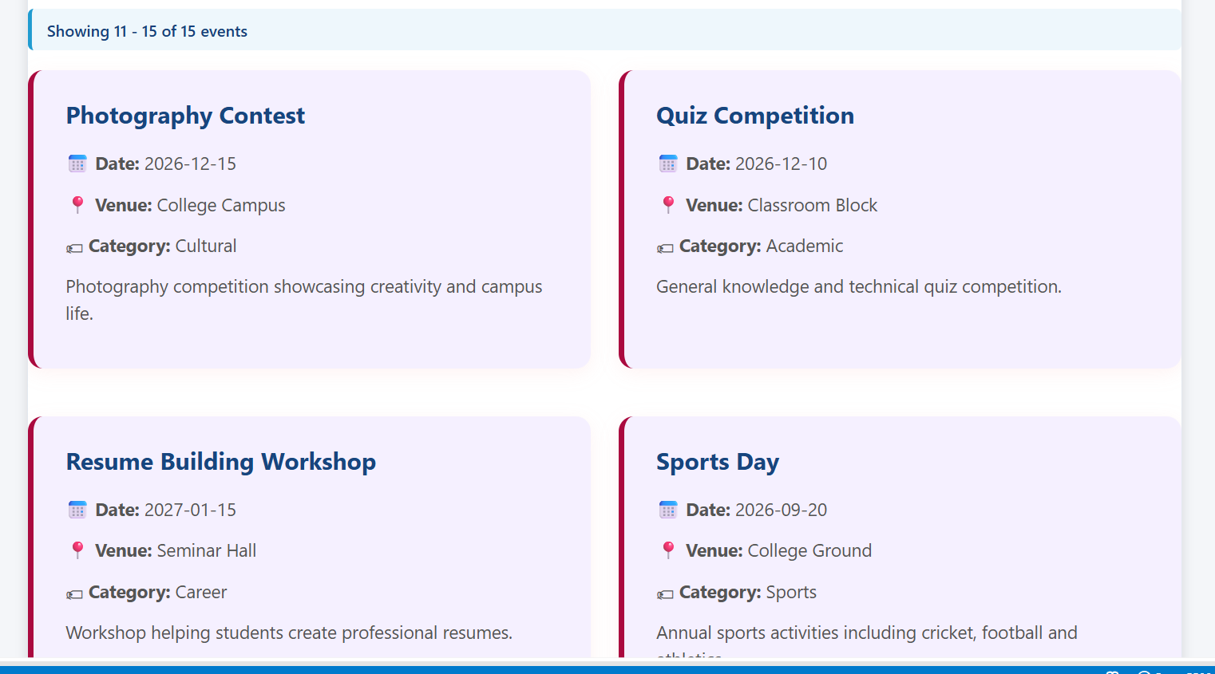

Loading / Error

Code:
Html
<div id="loadingMessage" class="info-box">
<p>
Loading events...
</p>
</div>
Js
if (loadingMessage) {
loadingMessage.style.display = "none";
}
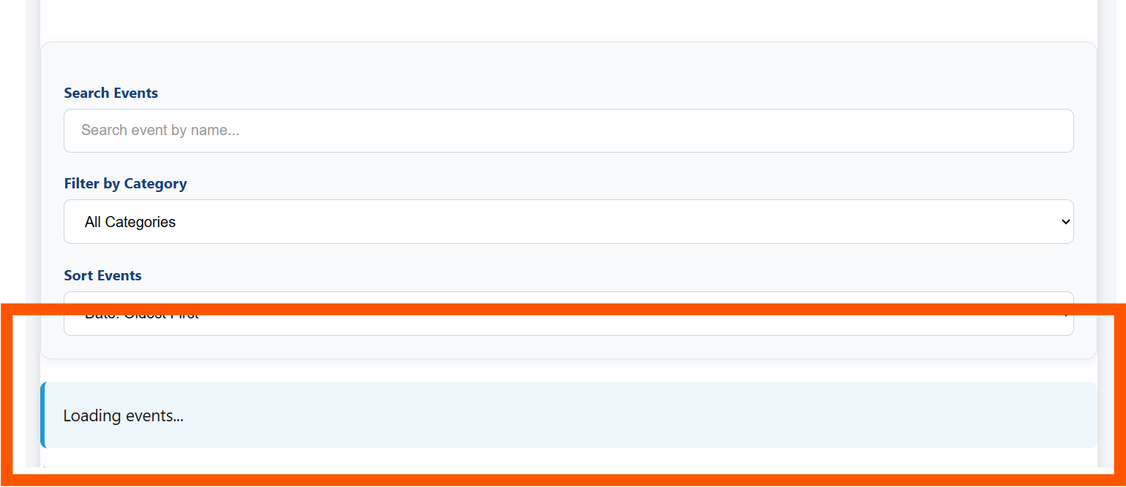

Error
Html
<div
id="errorMessage"
class="error-box"
style="display:none;"
>
<p>
Unable to load events. Please try again later.
</p>
</div>

Js
.catch(function (error) {

console.error(
"Fetch Error:",
error
);

if (loadingMessage) {
loadingMessage.style.display = "none";
}

if (errorMessage) {
errorMessage.style.display = "block";
}
});

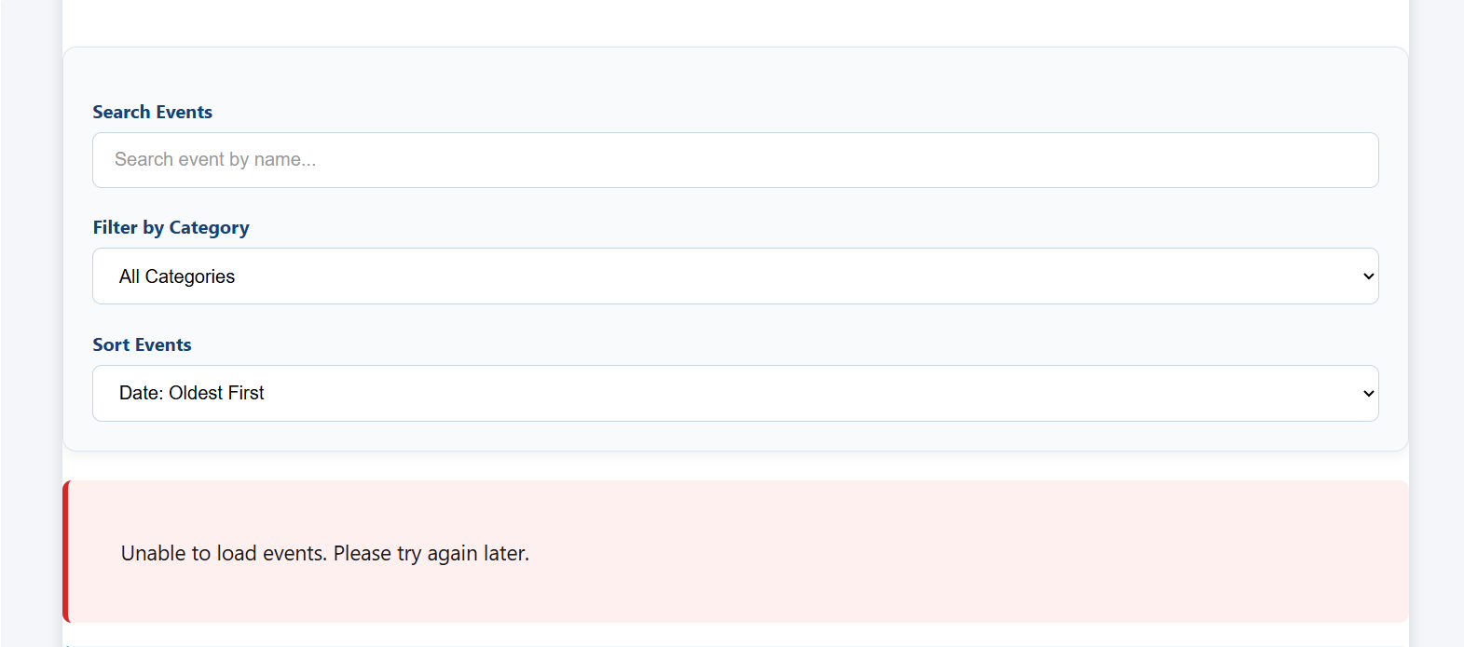

ALL CODES

Event.html
<!DOCTYPE html>
<html lang="en">

<head>

<meta charset="UTF-8">

<meta name="viewport" content="width=device-width, initial-scale=1.0">

<title>StudentHub | Events</title>

<link rel="stylesheet" href="style4.css">

</head>

<body>

<!-- ===============================
HEADER
================================ -->

<header>

<div class="container">

<div class="top">

<div class="logo">

<img src="image.jpg" alt="StudentHub Logo">

<div>

<h1>StudentHub</h1>

<h3>Student Management Portal</h3>

</div>

</div>

<button class="theme-btn" id="themeBtn">
🌙 Dark Mode
</button>

</div>

</div>

</header>

<!-- ===============================
NAVIGATION
================================ -->

<div class="nav-section">

<div class="container">

<div class="menu" id="menuBtn">☰</div>

<nav id="navbar">

<a href="home.html">Home</a>

<a href="about.html">About</a>

<a href="register.html">Register</a>

<a href="login.html">Login</a>

<a href="dashboard.html">Dashboard</a>

<a href="profile.html">Profile</a>

<a href="event.html">Events</a>

<a href="fees.html">Fees</a>

<a href="result.html">Result</a>

<a href="FAQ.html">FAQ</a>

<a href="logout.html">Logout</a>

</nav>

</div>

</div>

<!-- ===============================
MAIN
================================ -->

<main>

<!-- =====================================
PRACTICAL 6 : EVENT DATA SECTION
====================================== -->

<div class="card">

<h2>Upcoming Events</h2>

<p>
Explore upcoming StudentHub events using
search, filter and sorting options.
</p>

<!-- ===============================
SEARCH AND FILTER
================================ -->

<div class="event-controls">

<!-- Search -->

<div class="event-control">

<label for="eventSearch">
Search Events
</label>

<input
type="text"
id="eventSearch"
placeholder="Search event by name..."
>

</div>

<!-- Category Filter -->

<div class="event-control">

<label for="categoryFilter">
Filter by Category
</label>

<select id="categoryFilter">

<option value="all">
All Categories
</option>

</select>

</div>

<!-- Sort -->

<div class="event-control">

<label for="sortEvents">
Sort Events
</label>

<select id="sortEvents">

<option value="date-asc">
Date: Oldest First
</option>

<option value="date-desc">
Date: Newest First
</option>

<option value="title-asc">
Title: A-Z
</option>

<option value="title-desc">
Title: Z-A
</option>

</select>

</div>

</div>

<!-- ===============================
LOADING MESSAGE
================================ -->

<div id="loadingMessage" class="info-box">

<p>
Loading events...
</p>

</div>

<!-- ===============================
ERROR MESSAGE
================================ -->

<div
id="errorMessage"
class="error-box"
style="display:none;"
>

<p>
Unable to load events. Please try again later.
</p>

</div>

<!-- ===============================
EVENT COUNT
================================ -->

<div id="eventCount" class="event-count"></div>

<!-- ===============================
DYNAMIC EVENT CARDS
================================ -->

<div id="eventContainer" class="event-container">

<!-- Events will be displayed here using JavaScript -->

</div>

<!-- ===============================
NO RESULTS MESSAGE
================================ -->

<div
id="noEvents"
class="warning-box"
style="display:none;"
>
<p>No events found.</p>
</div>

<!-- ===============================
PAGINATION
================================ -->

<div id="pagination" class="pagination"></div>

<!-- ===============================
NO RESULTS MESSAGE
================================ -->

<div
id="noEvents"
class="warning-box"
style="display:none;"
>

<p>
No events found.
</p>

</div>

<!-- ===============================
PAGINATION
================================ -->

<div
id="pagination"
class="pagination"
></div>

</div>

<!-- =====================================
EVENT CATEGORIES
====================================== -->

<div class="event-grid">

<div class="card">

<h2>Event Categories</h2>

<ul>

<li>Technical Events</li>

<li>Sports Activities</li>

<li>Cultural Programs</li>

<li>Workshops & Seminars</li>

<li>Coding Competitions</li>

<li>Industrial Visits</li>

<li>Guest Lectures</li>

<li>Career Guidance Programs</li>

</ul>

</div>

<!-- =====================================
LATEST ANNOUNCEMENTS
====================================== -->

<div class="card">

<h2>Latest Announcements</h2>

<ul>

<li>
Hackathon 2026 registration is open.
</li>

<li>
Sports Day participant registration is open.
</li>

<li>
Students must carry their College ID Card
during all events.
</li>

<li>
Workshop participation certificates
will be provided.
</li>

<li>
Cultural Fest auditions will begin soon.
</li>

<li>
For event-related queries, contact the
Student Activity Coordinator.
</li>

</ul>

</div>

<!-- =====================================
UPCOMING HIGHLIGHTS
====================================== -->

<div class="card">

<h2>Upcoming Highlights</h2>

<p>

StudentHub regularly organizes technical,
cultural, sports and educational events to
improve students' practical knowledge,
teamwork, leadership skills and overall
personality development.

Students are encouraged to participate
actively in different events throughout
the academic year.

</p>

</div>

</div>

<!-- =====================================
CONTACT US
====================================== -->

<div class="card contact-card">

<h2>Contact Us</h2>

<div class="contact-info">

<h3>StudentHub Portal</h3>

<p>
📧 Email : studenthub@gmail.com
</p>

<p>
📞 Phone : +91 9876543210
</p>

<p>
📍 Address : CHARUSAT Campus,
Changa, Gujarat 388421
</p>

</div>

</div>

</main>

<!-- ===============================
FOOTER
================================ -->

<footer>

<div class="footer-content">

<h2>StudentHub Portal</h2>

<p>
Empowering Students Through Technology
</p>

<p class="email">
Email : studenthub@gmail.com
</p>

<p class="copyright">
&copy; 2026 StudentHub. All Rights Reserved.
</p>

</div>

</footer>

<!-- ===============================
JAVASCRIPT
================================ -->

<script src="myscript.js"></script>

</body>

</html>

Events.json
[
{
"id": 1,
"title": "Hackathon 2026",
"date": "2026-08-10",
"venue": "Computer Lab",
"category": "Technical",
"description": "A coding hackathon where students develop innovative solutions."
},
{
"id": 2,
"title": "Sports Day",
"date": "2026-09-20",
"venue": "College Ground",
"category": "Sports",
"description": "Annual sports activities including cricket, football and athletics."
},
{
"id": 3,
"title": "Cultural Fest",
"date": "2026-10-15",
"venue": "Auditorium",
"category": "Cultural",
"description": "A cultural celebration featuring music, dance and drama."
},
{
"id": 4,
"title": "Web Development Workshop",
"date": "2026-10-25",
"venue": "Seminar Hall",
"category": "Workshop",
"description": "Hands-on workshop covering HTML, CSS and JavaScript."
},
{
"id": 5,
"title": "Coding Competition",
"date": "2026-11-05",
"venue": "Programming Lab",
"category": "Technical",
"description": "Competitive programming event for students."
},
{
"id": 6,
"title": "Industrial Visit",
"date": "2026-11-12",
"venue": "Ahmedabad",
"category": "Industrial Visit",
"description": "Educational industrial visit to understand real-world technology."
},
{
"id": 7,
"title": "Guest Lecture on AI",
"date": "2026-11-20",
"venue": "Conference Hall",
"category": "Guest Lecture",
"description": "Expert lecture introducing students to Artificial Intelligence."
},
{
"id": 8,
"title": "Career Guidance Program",
"date": "2026-11-28",
"venue": "Seminar Hall",
"category": "Career",
"description": "Career guidance session covering higher studies and job opportunities."
},
{
"id": 9,
"title": "Java Programming Workshop",
"date": "2026-12-03",
"venue": "Computer Lab",
"category": "Workshop",
"description": "Practical workshop on Java programming and object-oriented concepts."
},
{
"id": 10,
"title": "Quiz Competition",
"date": "2026-12-10",
"venue": "Classroom Block",
"category": "Academic",
"description": "General knowledge and technical quiz competition."
},
{
"id": 11,
"title": "Photography Contest",
"date": "2026-12-15",
"venue": "College Campus",
"category": "Cultural",
"description": "Photography competition showcasing creativity and campus life."
},
{
"id": 12,
"title": "Football Tournament",
"date": "2026-12-20",
"venue": "College Ground",
"category": "Sports",
"description": "Inter-department football tournament for students."
},
{
"id": 13,
"title": "Cyber Security Seminar",
"date": "2027-01-08",
"venue": "Conference Hall",
"category": "Technical",
"description": "Seminar on cyber security, online safety and ethical hacking."
},
{
"id": 14,
"title": "Resume Building Workshop",
"date": "2027-01-15",
"venue": "Seminar Hall",
"category": "Career",
"description": "Workshop helping students create professional resumes."
},
{
"id": 15,
"title": "Annual College Day",
"date": "2027-01-25",
"venue": "Main Auditorium",
"category": "Cultural",
"description": "Annual college celebration with student performances and awards."
}
]

Myscript.js
/* ======================================
NOTIFICATION BANNER CLOSE
====================================== */

const banner = document.getElementById("banner");
const closeBanner = document.getElementById("closeBanner");

if (closeBanner && banner) {

closeBanner.addEventListener("click", function () {

banner.style.display = "none";

});

}

/* ======================================
IMAGE / CONTENT SLIDER
====================================== */

const slider = document.getElementById("slider");

const slides = [

"📖 Welcome to StudentHub FAQ Center",

"🎓 Student Registration Made Easy",

"📢 Check Latest Events & Announcements",

"💳 View Fees & Payment Details",

"🏆 Access Your Semester Results"

];

let current = 0;

if (slider) {

setInterval(function () {

current++;

if (current >= slides.length) {

current = 0;

}

slider.innerHTML = slides[current];

}, 3000);

}

/* ======================================
FAQ COLLAPSIBLE
====================================== */

const faqButtons = document.querySelectorAll(".faq-btn");

faqButtons.forEach(function (button) {

button.addEventListener("click", function () {

const answer = this.nextElementSibling;
const icon = this.querySelector("span");

document.querySelectorAll(".faq-answer").forEach(function (item) {

if (item !== answer) {

item.style.display = "none";

}

});

document.querySelectorAll(".faq-btn span").forEach(function (item) {

if (item !== icon && item) {

item.innerHTML = "+";

}

});

if (answer && answer.style.display === "block") {

answer.style.display = "none";

if (icon) {

icon.innerHTML = "+";

}

}

else if (answer) {

answer.style.display = "block";

if (icon) {

icon.innerHTML = "−";

}

}

});

});

/* ======================================
MODAL POPUP
====================================== */

const modal = document.getElementById("supportModal");
const openModal = document.getElementById("openModal");
const closeModal = document.getElementById("closeModal");

if (openModal && modal) {

openModal.addEventListener("click", function () {

modal.style.display = "block";

});

}

if (closeModal && modal) {

closeModal.addEventListener("click", function () {

modal.style.display = "none";

});

}

window.addEventListener("click", function (event) {

if (event.target === modal) {

modal.style.display = "none";

}

});

/* ======================================
DARK / LIGHT THEME
====================================== */

const themeBtn = document.getElementById("themeBtn");

if (localStorage.getItem("theme") === "dark") {

document.body.classList.add("dark");

if (themeBtn) {

themeBtn.innerHTML = "☀ Light Mode";

}

}

if (themeBtn) {

themeBtn.addEventListener("click", function () {

document.body.classList.toggle("dark");

if (document.body.classList.contains("dark")) {

themeBtn.innerHTML = "☀ Light Mode";

localStorage.setItem("theme", "dark");

}

else {

themeBtn.innerHTML = "🌙 Dark Mode";

localStorage.setItem("theme", "light");

}

});

}

/* ======================================
HAMBURGER MENU
====================================== */

const menuBtn = document.getElementById("menuBtn");
const navbar = document.getElementById("navbar");

if (menuBtn && navbar) {

menuBtn.addEventListener("click", function () {

if (navbar.style.display === "flex") {

navbar.style.display = "none";

}

else {

navbar.style.display = "flex";

navbar.style.flexDirection = "column";

navbar.style.alignItems = "center";

}

});

}

/* ======================================
REGISTER FORM VALIDATION
====================================== */

const registerForm = document.getElementById("registerForm");

if (registerForm) {

const resetBtn = document.getElementById("resetBtn");

/* ---------- RESET ---------- */

if (resetBtn) {

resetBtn.addEventListener("click", function () {

document.querySelectorAll(".error-msg").forEach(function (el) {

el.innerText = "";

});

const successMsg = document.getElementById("successMsg");

if (successMsg) {

successMsg.innerText = "";

}

const passwordStrength =
document.getElementById("passwordStrength");

if (passwordStrength) {

passwordStrength.innerText = "";

passwordStrength.className = "password-strength";

}

});

}

/* ---------- PASSWORD STRENGTH ---------- */

const passwordInput = document.getElementById("password");

const passwordStrength =
document.getElementById("passwordStrength");

if (passwordInput && passwordStrength) {

passwordInput.addEventListener("input", function () {

const password = passwordInput.value;

if (password === "") {

passwordStrength.innerText = "";

passwordStrength.className = "password-strength";

return;

}

let score = 0;

if (password.length >= 8) {

score++;

}

if (/[a-z]/.test(password)) {

score++;

}

if (/[A-Z]/.test(password)) {

score++;

}

if (/[0-9]/.test(password)) {

score++;

}

if (/[@$!%*?&]/.test(password)) {

score++;

}

if (score <= 2) {

passwordStrength.innerText =
"Password Strength: Weak";

passwordStrength.className =
"password-strength weak";

}

else if (score <= 4) {

passwordStrength.innerText =
"Password Strength: Medium";

passwordStrength.className =
"password-strength medium";

}

else {

passwordStrength.innerText =
"Password Strength: Strong";

passwordStrength.className =
"password-strength strong";

}

});

}

/* ---------- SUBMIT ---------- */

registerForm.addEventListener("submit", function (event) {

event.preventDefault();

let isValid = true;

/* Clear old errors */

document.querySelectorAll(".error-msg").forEach(function (el) {

el.innerText = "";

});

const successMsg = document.getElementById("successMsg");

if (successMsg) {

successMsg.innerText = "";

}

/* ---------- ELEMENTS ---------- */

const nameInput =
document.getElementById("name");

const enrollmentInput =
document.getElementById("enrollment");

const rollInput =
document.getElementById("Roll-no.");

const emailInput =
document.getElementById("email");

const mobileInput =
document.getElementById("mobile");

const courseInput =
document.getElementById("course");

const yearInput =
document.getElementById("year");

const genderInputs =
document.getElementsByName("gender");

const passwordInput =
document.getElementById("password");

const confirmInput =
document.getElementById("confirm");

const termsInput =
document.getElementById("terms");

/* ---------- VALUES ---------- */

const nameVal =
nameInput ? nameInput.value.trim() : "";

const enrollmentVal =
enrollmentInput ? enrollmentInput.value.trim() : "";

const rollVal =
rollInput ? rollInput.value.trim() : "";

const emailVal =
emailInput ? emailInput.value.trim() : "";

const mobileVal =
mobileInput ? mobileInput.value.trim() : "";

const courseVal =
courseInput ? courseInput.value : "";

const yearVal =
yearInput ? yearInput.value : "";

const passwordVal =
passwordInput ? passwordInput.value : "";

const confirmVal =
confirmInput ? confirmInput.value : "";

/* ======================================
1. FULL NAME
====================================== */

const nameRegex = /^[A-Za-z\s]+$/;

if (nameInput) {

if (nameVal === "") {

document.getElementById("nameError").innerText =
"Please enter your Full Name.";

isValid = false;

}

else if (!nameRegex.test(nameVal)) {

document.getElementById("nameError").innerText =
"Full Name must contain only alphabets.";

isValid = false;

}

}

/* ======================================
2. ENROLLMENT NUMBER
====================================== */

const enrollmentError =
document.getElementById("enrollmentError");

const enrollmentPattern =
/^[Dd]?[0-9]{2}[a-zA-Z]{2}[0-9]{3}$/;

if (enrollmentInput) {

if (enrollmentVal === "") {

enrollmentError.innerText =
"Please enter Enrollment Number.";

isValid = false;

}

else if (!enrollmentPattern.test(enrollmentVal)) {

enrollmentError.innerText =
"Invalid format! Example: 25CS063 or D25CS063.";

isValid = false;

}

}

/* ======================================
3. ROLL NUMBER
====================================== */

if (rollInput) {

const rollError =
document.getElementById("Roll-no.");

const rollPattern =
/^[0-9]{1,3}$/;

if (rollVal === "") {

rollError.innerText =
"Please enter Roll Number.";

isValid = false;

}

else if (!rollPattern.test(rollVal)) {

rollError.innerText =
"Roll Number must contain 1 to 3 digits.";

isValid = false;

}

}

/* ======================================
4. EMAIL
====================================== */

const emailRegex =
/^[a-z0-9._%+-]+@[a-z0-9.-]+\.[a-z]{2,}$/;

if (emailInput) {

if (emailVal === "") {

document.getElementById("emailError").innerText =
"Please enter your Email Address.";

isValid = false;

}

else if (!emailRegex.test(emailVal)) {

document.getElementById("emailError").innerText =
"Email must contain lowercase letters only with proper format.";

isValid = false;

}

}

/* ======================================
5. MOBILE
====================================== */

const mobileRegex =
/^[6-9][0-9]{9}$/;

if (mobileInput) {

if (mobileVal === "") {

document.getElementById("mobileError").innerText =
"Please enter your Mobile Number.";

isValid = false;

}

else if (!mobileRegex.test(mobileVal)) {

document.getElementById("mobileError").innerText =
"Please enter a valid 10-digit Indian Mobile Number.";

isValid = false;

}

}

/* ======================================
6. COURSE
====================================== */

if (courseInput) {

if (courseVal === "") {

document.getElementById("courseError").innerText =
"Please select a Course.";

isValid = false;

}

}

/* ======================================
7. ACADEMIC YEAR
====================================== */

if (yearInput) {

if (yearVal === "") {

document.getElementById("yearError").innerText =
"Please select your Academic Year.";

isValid = false;

}

}

/* ======================================
8. GENDER
====================================== */

if (genderInputs.length > 0) {

let genderSelected = false;

for (let g of genderInputs) {

if (g.checked) {

genderSelected = true;

break;

}

}

if (!genderSelected) {

document.getElementById("genderError").innerText =
"Please select your Gender.";

isValid = false;

}

}

/* ======================================
9. PASSWORD
====================================== */

const passwordRegex =
/^(?=.*[a-z])(?=.*[A-Z])(?=.*\d)(?=.*[@$!%*?&])[A-Za-z\d@$!%*?&]{8,}$/;

if (passwordInput) {

if (passwordVal === "") {

document.getElementById("passwordError").innerText =
"Please enter a Password.";

isValid = false;

}

else if (!passwordRegex.test(passwordVal)) {

document.getElementById("passwordError").innerText =
"Password must be min 8 chars with 1 uppercase, 1 lowercase, 1 digit, and 1 special symbol.";

isValid = false;

}

}

/* ======================================
10. CONFIRM PASSWORD
====================================== */

if (confirmInput) {

if (confirmVal === "") {

document.getElementById("confirmError").innerText =
"Password and Confirm Password do not match.";

isValid = false;

}

else if (passwordVal !== confirmVal) {

document.getElementById("confirmError").innerText =
"Password and Confirm Password do not match.";

isValid = false;

}

}

/* ======================================
11. TERMS
====================================== */

if (termsInput) {

if (!termsInput.checked) {

document.getElementById("termsError").innerText =
"You must agree to the Terms and Conditions.";

isValid = false;

}

}

/* ======================================
SUCCESS
====================================== */

if (isValid) {

if (successMsg) {

successMsg.innerText =
"✓ Registration Completed Successfully!";

}

registerForm.reset();

if (passwordStrength) {

passwordStrength.innerText = "";

passwordStrength.className =
"password-strength";

}

}

});

}

/* ==================================================
PRACTICAL 6
FETCH API + EXTERNAL JSON EVENTS
SEARCH + FILTER + SORT + PAGINATION
================================================== */

(function () {

/* ======================================
EVENT PAGE ELEMENTS
====================================== */

const eventContainer =
document.getElementById("eventContainer");

const eventSearch =
document.getElementById("eventSearch");

const categoryFilter =
document.getElementById("categoryFilter");

const sortEvents =
document.getElementById("sortEvents");

const pagination =
document.getElementById("pagination");

const loadingMessage =
document.getElementById("loadingMessage");

const errorMessage =
document.getElementById("errorMessage");

const noEvents =
document.getElementById("noEvents");

const eventCount =
document.getElementById("eventCount");

/* ======================================
RUN ONLY ON EVENT PAGE
====================================== */

if (!eventContainer) {

return;

}

/* ======================================
VARIABLES
====================================== */

let allEvents = [];

let filteredEvents = [];

let currentPage = 1;

const eventsPerPage = 5;

/* ======================================
FETCH JSON DATA
====================================== */

fetch("events.json")

.then(function (response) {

if (!response.ok) {

throw new Error(
"Unable to load events.json"
);

}

return response.json();

})

.then(function (data) {

allEvents = data;

filteredEvents = [...allEvents];

/* Hide loading */

if (loadingMessage) {

loadingMessage.style.display = "none";

}

/* Create categories */

createCategories();

/* Display events */

displayEvents();

})

.catch(function (error) {

console.error(
"Fetch Error:",
error
);

if (loadingMessage) {

loadingMessage.style.display = "none";

}

if (errorMessage) {

errorMessage.style.display = "block";

}

});

/* ======================================
CREATE CATEGORY OPTIONS
====================================== */

function createCategories() {

if (!categoryFilter) {

return;

}

const categories = [];

allEvents.forEach(function (event) {

if (
event.category &&
!categories.includes(event.category)
) {

categories.push(event.category);

}

});

categories.sort();

categories.forEach(function (category) {

const option =
document.createElement("option");

option.value = category;

option.textContent = category;

categoryFilter.appendChild(option);

});

}

/* ======================================
DISPLAY EVENTS
====================================== */

function displayEvents() {

if (!eventContainer) {

return;

}

eventContainer.innerHTML = "";

if (noEvents) {

noEvents.style.display = "none";

}

/* No result */

if (filteredEvents.length === 0) {

if (noEvents) {

noEvents.style.display = "block";

}

if (eventCount) {

eventCount.innerText =
"0 events found.";

}

if (pagination) {

pagination.innerHTML = "";

}

return;

}

/* ======================================
PAGINATION CALCULATION
====================================== */

const startIndex =
(currentPage - 1) * eventsPerPage;

const endIndex =
startIndex + eventsPerPage;

const pageEvents =
filteredEvents.slice(
startIndex,
endIndex
);

/* ======================================
EVENT COUNT
====================================== */

if (eventCount) {

eventCount.innerText =
"Showing " +
(startIndex + 1) +
" - " +
Math.min(
endIndex,
filteredEvents.length
) +
" of " +
filteredEvents.length +
" events";

}

/* ======================================
CREATE EVENT CARDS
====================================== */

pageEvents.forEach(function (event) {

const card =
document.createElement("div");

card.className = "event-card";

const title =
document.createElement("h3");

title.textContent =
event.title;

const date =
document.createElement("p");

date.innerHTML =
"<strong>📅 Date:</strong> " +
event.date;

const venue =
document.createElement("p");

venue.innerHTML =
"<strong>📍 Venue:</strong> " +
event.venue;

const category =
document.createElement("p");

category.innerHTML =
"<strong>🏷 Category:</strong> " +
event.category;

const description =
document.createElement("p");

description.textContent =
event.description;

card.appendChild(title);

card.appendChild(date);

card.appendChild(venue);

card.appendChild(category);

card.appendChild(description);

eventContainer.appendChild(card);

});

/* Create pagination */

createPagination();

}

/* ======================================
PAGINATION
====================================== */

function createPagination() {

if (!pagination) {

return;

}

pagination.innerHTML = "";

const totalPages =
Math.ceil(
filteredEvents.length /
eventsPerPage
);

if (totalPages <= 1) {

return;

}

/* Previous Button */

const previousButton =
document.createElement("button");

previousButton.innerText =
"Previous";

previousButton.disabled =
currentPage === 1;

previousButton.addEventListener(
"click",
function () {

if (currentPage > 1) {

currentPage--;

displayEvents();

}

}
);

pagination.appendChild(
previousButton
);

/* Page Numbers */

for (
let page = 1;
page <= totalPages;
page++
) {

const pageButton =
document.createElement("button");

pageButton.innerText =
page;

if (page === currentPage) {

pageButton.classList.add(
"active-page"
);

}

pageButton.addEventListener(
"click",
function () {

currentPage = page;

displayEvents();

}
);

pagination.appendChild(
pageButton
);

}

/* Next Button */

const nextButton =
document.createElement("button");

nextButton.innerText =
"Next";

nextButton.disabled =
currentPage === totalPages;

nextButton.addEventListener(
"click",
function () {

if (
currentPage <
totalPages
) {

currentPage++;

displayEvents();

}

}
);

pagination.appendChild(
nextButton
);

}

/* ======================================
SEARCH EVENTS
====================================== */

if (eventSearch) {

eventSearch.addEventListener(
"input",
function () {

applyFilters();

}
);

}

/* ======================================
CATEGORY FILTER
====================================== */

if (categoryFilter) {

categoryFilter.addEventListener(
"change",
function () {

applyFilters();

}
);

}

/* ======================================
SORT EVENTS
====================================== */

if (sortEvents) {

sortEvents.addEventListener(
"change",
function () {

applyFilters();

}
);

}

/* ======================================
SEARCH + FILTER + SORT
====================================== */

function applyFilters() {

const searchText =
eventSearch
? eventSearch.value
.trim()
.toLowerCase()
: "";

const selectedCategory =
categoryFilter
? categoryFilter.value
: "all";

const selectedSort =
sortEvents
? sortEvents.value
: "date-asc";

/* ======================================
SEARCH + CATEGORY FILTER
====================================== */

filteredEvents =
allEvents.filter(function (event) {

const title =
event.title
? event.title.toLowerCase()
: "";

const category =
event.category
? event.category.toLowerCase()
: "";

const venue =
event.venue
? event.venue.toLowerCase()
: "";

const matchesSearch =
title.includes(searchText) ||
category.includes(searchText) ||
venue.includes(searchText);

const matchesCategory =
selectedCategory === "all" ||
event.category ===
selectedCategory;

return (
matchesSearch &&
matchesCategory
);

});

/* ======================================
SORT
====================================== */

filteredEvents.sort(
function (a, b) {

if (selectedSort === "title-asc") {

return a.title.localeCompare(
b.title
);

}

if (selectedSort === "title-desc") {

return b.title.localeCompare(
a.title
);

}

if (selectedSort === "date-desc") {

return new Date(b.date) -
new Date(a.date);

}

return new Date(a.date)
new Date(b.date);

}
);

/* Reset to first page */

currentPage = 1;

/* Display */

displayEvents();

}

})();

Style.4css
/*==================================================
STUDENTHUB NEW THEME (PART-1)
==================================================*/

*{
margin:0;
padding:0;
box-sizing:border-box;
}

html{
scroll-behavior:smooth;
}

body{
font-family:'Segoe UI',Tahoma,sans-serif;
background:#F4F6F9;
color:#333;
transition:.4s;
}

/*==================== CONTAINER ====================*/

.container{
width:92%;
max-width:1400px;
margin:auto;
}

/*==================== HEADER ====================*/

header {
background: linear-gradient(135deg, #182E5A, #1F3B73);
min-height: 220px;
display: flex;
align-items: center;
padding: 30px 0;
box-shadow: 0 6px 20px rgba(0, 0, 0, .25);
border-bottom: 4px solid #2098D1;
position: relative;
}

/*==================== TOP ====================*/

.top {
display: flex;
justify-content: space-between;
align-items: center;
width: 100%;
}

/*==================== LOGO & MAIN TITLE ====================*/

.logo {
display: flex;
align-items: center;
gap: 20px;
}

.logo img {
width: 130px;
height: 130px;
border-radius: 50%;
background: white;
padding: 8px;
margin-right: 25px;
box-shadow: 0 8px 20px rgba(0, 0, 0, .30);
border: 3px solid #2098D1;
transition: transform .35s ease;
}

.logo img:hover {
transform: scale(1.05);
}

.logo h1 {
font-size: 68px;
color: #FFFFFF;
font-weight: 800;
letter-spacing: 1.5px;
text-shadow: 0 3px 10px rgba(0, 0, 0, .35);
line-height: 1.1;
}

.logo h3 {
margin-top: 10px;
color: #E0E9F8;
font-size: 28px;
font-weight: 500;
letter-spacing: 0.8px;
}

/*==================== NAVIGATION ====================*/

.nav-section{
background:#294B8A;
box-shadow:0 3px 10px rgba(0,0,0,.15);
}

nav{
width:100%;
display:flex;
justify-content:center;
align-items:center;
gap:10px;
padding:15px 0;
flex-wrap:wrap;
}

nav a{
color:white;
text-decoration:none;
padding:10px 16px;
font-size:16px;
font-weight:600;
border-radius:5px;
transition:.3s;
}

nav a:hover{
background:#3F79D6;
}

/*==================================================
STUDENTHUB NEW THEME (PART-2)
MAIN • CARDS • TITLES • CONTENT
==================================================*/

main{
width:92%;
max-width:1400px;
margin:35px auto;
}

/*==================== CARD ====================*/

.card{
background:white;
border-radius:10px;
margin-bottom:30px;
overflow:hidden;
box-shadow:0 4px 12px rgba(0,0,0,.12);
border:1px solid #E3E8EF;
}

.card h2{
background:#2098D1;
color:white;
font-size:28px;
font-weight:600;
padding:18px 25px;
margin:0;
border:none;
}

.card p,
.card address,
.card ul,
.card ol{
padding:25px;
font-size:18px;
line-height:1.8;
color:#1d1a1a;
}

/*==================== CONTACT CARD COMPACT FIX ====================*/

.contact-card {
padding: 0 !important;
overflow: hidden;
}

.contact-card h2 {
margin: 0 !important;
padding: 8px 15px !important;
font-size: 18px !important;
}

.contact-info {
padding: 10px 15px !important;
}

.contact-info h3 {
margin: 0 0 4px 0 !important;
padding: 0 !important;
font-size: 16px !important;
color: #1F3B73 !important;
}

.contact-info p {
margin: 2px 0 !important;
padding: 0 !important;
font-size: 14px !important;
color: #333 !important;
line-height: 1.2 !important;
}

/*==================== SERVICES SECTION ALIGNMENT FIX ====================*/

.services {
padding: 25px;
display: flex;
flex-direction: column;
gap: 20px;
}

.service {
margin-bottom: 5px;
}

.service h3 {
color: #1F3B73;
font-size: 22px;
margin-bottom: 8px;
padding: 0;
}

.service p {
padding: 0 !important;
font-size: 17px;
color: #444;
line-height: 1.6;
}

/*==================== WELCOME SECTION ====================*/

.welcome-box{
background:white;
border-left:6px solid #2098D1;
padding:35px;
border-radius:10px;
margin-bottom:30px;
box-shadow:0 4px 12px rgba(0,0,0,.10);
}

.welcome-box h2{
color:#1F3B73;
background:none;
padding:0;
font-size:42px;
margin-bottom:18px;
}

.welcome-box p{
padding:0;
font-size:20px;
color:#555;
}

/*==================== SECTION SPACING & HEADING ====================*/

section{
margin-bottom:35px;
}

h3{
color:#1F3B73;
margin-bottom:15px;
}

hr{
border:none;
border-top:1px solid #D8DEE8;
margin:30px 0;
}

a{
transition:.3s;
}

a:hover{
text-decoration:none;
}

address{
font-style:normal;
line-height:2;
}

/*==================================================
STUDENTHUB NEW THEME (PART-3)
BUTTONS • FAQ • CONTACT BUTTON
==================================================*/

button{
font-family:'Segoe UI',sans-serif;
cursor:pointer;
transition:.3s;
border:none;
outline:none;
}

/*==================== FAQ BUTTON ====================*/

.faq-btn{
width:100%;
background:white;
color:#1F3B73;
padding:18px 22px;
margin:0;
border:none;
border-bottom:1px solid #dcf0df;
display:flex;
justify-content:space-between;
align-items:center;
font-size:18px;
font-weight:600;
cursor:pointer;
transition:.3s;
}

.faq-btn:hover{
background:#F4F9FF;
color:#2098D1;
padding-left:30px;
}

.faq-answer{
display:none;
background:#FAFCFF;
padding:20px 25px;
color:#444;
font-size:18px;
font-weight:500;
line-height:1.8;
opacity:1;
border-left:5px solid #2098D1;
border-bottom:1px solid #E3E8EF;
}

.faq-btn span{
font-size:22px;
color:#2098D1;
font-weight:bold;
}

/*==================== CONTACT & THEME BUTTONS ====================*/

.contact-btn,
#openModal{
background:#2098D1;
color:white;
padding:14px 30px;
font-size:17px;
font-weight:600;
border-radius:6px;
transition:.3s;
}

.contact-btn:hover,
#openModal:hover{
background:#1B7FB0;
transform:translateY(-2px);
box-shadow:0 6px 15px rgba(0,0,0,.18);
}

#closeModal{
background:#1F3B73;
color:white;
padding:12px 24px;
border-radius:6px;
transition:.3s;
}

#closeModal:hover{
background:#294B8A;
}

.theme-btn {
position: absolute;
top: 15px;
right: 20px;
padding: 6px 14px;
font-size: 13px;
font-weight: 600;
border: 1px solid rgba(255, 255, 255, 0.3);
border-radius: 20px;
background: rgba(255, 255, 255, 0.15);
color: #FFFFFF;
cursor: pointer;
white-space: nowrap;
backdrop-filter: blur(5px);
transition: all 0.3s ease;
z-index: 10;
}

.theme-btn:hover {
background: #2098D1;
border-color: #2098D1;
transform: translateY(-1px);
box-shadow: 0 4px 10px rgba(0, 0, 0, 0.2);
}

.btn{
background:#2098D1;
color:white;
padding:12px 25px;
border-radius:6px;
display:inline-block;
text-decoration:none;
transition:.3s;
}

.btn:hover{
background:#1B7FB0;
}

/*==================================================
STUDENTHUB NEW THEME (PART-4)
FORMS • INPUTS • LOGIN • REGISTER
==================================================*/

form {
width: 100%;
padding: 25px;
}

.form-field {
display: flex;
flex-direction: column;
}

.error-msg {
color: #dc2626;
font-size: 14px;
font-weight: 600;
margin-top: 4px;
display: block;
}

/* SUCCESS MESSAGE STYLING BELOW BUTTONS */
.success-display {
color: #16a34a;
font-size: 18px;
font-weight: 700;
margin-top: 15px;
}

/*==================== PASSWORD STRENGTH METER ====================*/

.password-strength {
margin-top: 8px;
font-size: 14px;
font-weight: 600;
min-height: 20px;
}

.password-strength.weak {
color: #dc2626;
}

.password-strength.medium {
color: #d97706;
}

.password-strength.strong {
color: #16a34a;
}

/* FIXED TERMS AND CONDITIONS CHECKBOX LAYOUT */
.terms-container {
display: flex;
align-items: center;
gap: 10px;
margin-top: 10px;
}

.terms-container input[type="checkbox"] {
margin: 0 !important;
width: 18px !important;
height: 18px !important;
cursor: pointer;
}

.terms-container label {
margin: 0 !important;
font-weight: normal !important;
cursor: pointer;
line-height: 1 !important;
}

label{
display:block;
margin-top:18px;
margin-bottom:8px;
font-size:16px;
font-weight:600;
color:#1F3B73;
}

input[type=text],
input[type=email],
input[type=password],
input[type=number],
input[type=date],
input[type=tel],
input[type=file],
select,
textarea{
width:100%;
padding:14px 16px;
border:1px solid #C8D3E0;
border-radius:6px;
font-size:16px;
background:white;
transition:.3s;
}

input:focus,
select:focus,
textarea:focus{
outline:none;
border-color:#2098D1;
box-shadow:0 0 8px rgba(32,152,209,.25);
}

textarea{
resize:vertical;
min-height:120px;
}

::placeholder{
color:#999;
}

input[type=radio],
input[type=checkbox]{
accent-color:#2098D1;
}

input[type=submit],
input[type=reset]{
background:#2098D1;
color:white;
border:none;
padding:14px 30px;
border-radius:6px;
font-size:17px;
font-weight:600;
cursor:pointer;
margin-top:25px;
margin-right:10px;
transition:.3s;
}

input[type=submit]:hover,
input[type=reset]:hover{
background:#1B7FB0;
transform:translateY(-2px);
box-shadow:0 5px 12px rgba(0,0,0,.15);
}

.form-row{
display:flex;
gap:20px;
flex-wrap:wrap;
}

.form-group{
flex:1;
min-width:250px;
}

.login-box{
max-width:500px;
margin:auto;
background:white;
padding:35px;
border-radius:10px;
box-shadow:0 5px 15px rgba(0,0,0,.15);
}

.register-box{
background:white;
padding:35px;
border-radius:10px;
box-shadow:0 5px 15px rgba(0,0,0,.12);
}

/*==================================================
STUDENTHUB NEW THEME (PART-5)
TABLES • RESULT • FEES
==================================================*/

table{
width:100%;
border-collapse:collapse;
margin-top:25px;
background:white;
box-shadow:0 5px 15px rgba(0,0,0,.12);
border-radius:8px;
overflow:hidden;
}

th{
background:#1F3B73;
color:white;
padding:16px;
font-size:16px;
font-weight:600;
text-align:center;
border-bottom:1px solid rgba(255, 255, 255, 0.2);
}

td{
padding:14px;
border-bottom:1px solid #E2E8F0;
text-align:center;
font-size:15px;
}

tr:nth-child(even){
background:#F7FAFC;
}

tr:hover{
background:#E8F4FF;
}

caption{
font-size:22px;
font-weight:bold;
color:#1F3B73;
margin-bottom:15px;
}

.pass, .paid{ color:#16A34A; font-weight:bold; }
.fail, .unpaid{ color:#DC2626; font-weight:bold; }
.pending{ color:#D97706; font-weight:bold; }

.table-container{
overflow-x:auto;
}

/*==================================================
STUDENTHUB NEW THEME (PART-6)
DASHBOARD • PROFILE • EVENT • INFO CARDS
==================================================*/

.dashboard-grid{
display:grid;
grid-template-columns:repeat(auto-fit,minmax(250px,1fr));
gap:25px;
margin-top:25px;
}

.dashboard-card{
background:white;
border-radius:10px;
padding:30px;
text-align:center;
box-shadow:0 5px 15px rgba(0,0,0,.12);
border-top:5px solid #2098D1;
transition:.3s;
}

.dashboard-card:hover{
transform:translateY(-6px);
box-shadow:0 10px 22px rgba(0,0,0,.18);
}

.dashboard-card h3{
color:#1F3B73;
margin-bottom:15px;
font-size:22px;
}

.dashboard-card p{
font-size:18px;
color:#666;
}

.profile-card{
background:white;
border-radius:10px;
padding:30px;
box-shadow:0 5px 15px rgba(0,0,0,.12);
text-align:center;
}

.profile-card img{
width:130px;
height:130px;
border-radius:50%;
border:4px solid #2098D1;
margin-bottom:20px;
}

.profile-card h2{
background:none;
color:#1F3B73;
padding:0;
margin-bottom:10px;
}

.profile-card p{
padding:0;
color:#666;
}

.event-card{
background:white;
border-left:6px solid #2098D1;
border-radius:10px;
padding:25px;
margin-bottom:20px;
box-shadow:0 4px 12px rgba(0,0,0,.10);
transition:.3s;
}

.event-card:hover{
transform:translateX(6px);
}

.event-card h3{
color:#1F3B73;
margin-bottom:10px;
}

.event-card p{
padding:0;
color:#555;
}

.info-box{
background:#EAF5FF;
border-left:5px solid #2098D1;
padding:20px;
border-radius:8px;
margin:20px 0;
}

.info-box h3{
color:#1F3B73;
margin-bottom:10px;
}

.info-box p{
padding:0;
}

.success-box{ background:#E8F8EC; border-left:5px solid #16A34A; padding:18px; border-radius:8px; margin:20px 0; }
.warning-box{ background:#FFF8E6; border-left:5px solid #D97706; padding:18px; border-radius:8px; margin:20px 0; }
.error-box{ background:#FDECEC; border-left:5px solid #DC2626; padding:18px; border-radius:8px; margin:20px 0; }

/*==================================================
STUDENTHUB NEW THEME (PART-7)
NOTIFICATION • SLIDER • MODAL • FOOTER • DARK MODE
==================================================*/

.banner{
background:#FFD54F;
color:#222;
padding:14px 20px;
text-align:center;
font-size:16px;
font-weight:600;
position:relative;
box-shadow:0 2px 8px rgba(0,0,0,.15);
}

.banner span{
position:absolute;
right:20px;
top:10px;
font-size:22px;
cursor:pointer;
}

.slider{
background:linear-gradient(135deg,#1F3B73,#2C82C9);
color:white;
text-align:center;
padding:45px;
border-radius:10px;
font-size:32px;
font-weight:600;
margin-bottom:30px;
box-shadow:0 5px 15px rgba(0,0,0,.18);
}

.modal{
display:none;
position:fixed;
left:0;
top:0;
width:100%;
height:100%;
background:rgba(0,0,0,.55);
z-index:1000;
}

.modal-content{
background:white;
width:420px;
max-width:90%;
margin:120px auto;
padding:30px;
border-radius:10px;
box-shadow:0 10px 25px rgba(0,0,0,.25);
animation:popup .35s;
}

@keyframes popup{
from{ transform:scale(.8); opacity:0; }
to{ transform:scale(1); opacity:1; }
}

footer {
background: #182E5A;
color: #FFFFFF;
text-align: center;
padding: 45px 20px;
margin-top: 50px;
width: 100%;
box-shadow: 0 -4px 15px rgba(0, 0, 0, 0.15);
}

.footer-content {
max-width: 1200px;
margin: 0 auto;
display: flex;
flex-direction: column;
align-items: center;
justify-content: center;
}

.footer-content h2 {
font-size: 26px;
font-weight: 700;
margin-bottom: 10px;
color: #FFFFFF;
letter-spacing: 0.5px;
}

.footer-content p {
font-size: 16px;
color: #D8E2F2;
margin: 4px 0;
}

.footer-content .email {
margin-top: 15px;
margin-bottom: 20px;
font-size: 15px;
color: #E0E9F8;
}

.footer-content .copyright {
font-size: 14px;
color: #A0B2D6;
}

/* ==================================================
🔥 PERFECT DARK MODE FIX 🔥
================================================== */

body.dark {
background: #121212 !important;
color: #ffffff !important;
}

body.dark .theme-btn {
background: #FFD54F !important;
color: #222222 !important;
border-color: #FFD54F !important;
}

body.dark .card,
body.dark .dashboard-card,
body.dark .profile-card,
body.dark .event-card,
body.dark .modal-content {
background-color: #1e293b !important;
background: #1e293b !important;
color: #ffffff !important;
border: 1px solid #334155 !important;
}

body.dark .card p,
body.dark .card address,
body.dark .card ul,
body.dark .card ol,
body.dark .card li,
body.dark .card h2,
body.dark .card h3 {
color: #ffffff !important;
}

body.dark .faq-btn {
background-color: #0f172a !important;
background: #0f172a !important;
color: #ffffff !important;
border-bottom: 1px solid #334155 !important;
}

body.dark .faq-btn:hover {
background-color: #1e293b !important;
color: #38bdf8 !important;
}

body.dark .faq-btn span {
color: #38bdf8 !important;
}

body.dark .faq-answer {
background-color: #1e293b !important;
background: #1e293b !important;
border-left: 5px solid #38bdf8 !important;
border-bottom: 1px solid #334155 !important;
}

body.dark .faq-answer p {
color: #ffffff !important;
font-weight: 500;
}

body.dark input,
body.dark textarea,
body.dark select {
background: #2A2A2A !important;
color: white !important;
border: 1px solid #555 !important;
}

body.dark table {
background: #1F1F1F !important;
}

body.dark td {
color: white !important;
}

body.dark tr:nth-child(even) {
background: #2A2A2A !important;
}

body.dark footer {
background: #0E1B37 !important;
}

body.dark label,
body.dark .form-group label,
body.dark form label {
color: #ffffff !important;
}

body.dark .error-msg {
color: #f87171 !important;
}

body.dark .success-display {
color: #4ade80 !important;
}

/* Modal Styling */
.modal {
display: none;
position: fixed;
z-index: 1000;
left: 0;
top: 0;
width: 100%;
height: 100%;
background-color: rgba(0, 0, 0, 0.6);
}

.modal-content {
background-color: #ffffff;
margin: 15% auto;
padding: 25px;
border-radius: 10px;
width: 90%;
max-width: 450px;
text-align: center;
box-shadow: 0 4px 15px rgba(0,0,0,0.3);
}

body.dark .modal-content {
background-color: #1e293b;
color: #ffffff;
}

/* =====================================================
PRACTICAL 6 - EVENT PAGE DESIGN
===================================================== */

/* ===============================
EVENT CONTROLS
================================ */

.event-controls {
margin: 35px 0 25px 0;
padding: 25px;
background: #f8fafc;
border-radius: 12px;
border: 1px solid #dbe4ee;
box-shadow: 0 3px 10px rgba(0, 0, 0, 0.06);
}

.event-control {
margin-bottom: 22px;
}

.event-control:last-child {
margin-bottom: 0;
}

.event-control label {
display: block;
margin-bottom: 8px;
font-weight: bold;
color: #173f7a;
}

.event-control input,
.event-control select {
width: 100%;
box-sizing: border-box;
padding: 14px 18px;
border: 1px solid #c8d5e3;
border-radius: 8px;
font-size: 16px;
background: white;
}

.event-control input:focus,
.event-control select:focus {
outline: none;
border-color: #209bd0;
box-shadow: 0 0 0 3px rgba(32, 155, 208, 0.15);
}

/* ===============================
EVENT COUNT
================================ */

.event-count {
margin: 20px 0 15px 0;
padding: 10px 15px;
font-size: 16px;
font-weight: 600;
color: #173f7a;
background: #eef7fc;
border-left: 4px solid #209bd0;
border-radius: 6px;
}

/* ===============================
EVENT CONTAINER
================================ */

.event-container {
display: flex;
flex-direction: column;
gap: 22px;
margin-top: 15px;
}

/* ===============================
INDIVIDUAL EVENT CARD
================================ */

.event-container > div,
.event-container > article,
.event-container > .event-card {
background: #ffffff;
border-radius: 12px;
padding: 25px 30px;
border-left: 6px solid #209bd0;
box-shadow: 0 5px 15px rgba(0, 0, 0, 0.10);
transition: transform 0.2s ease, box-shadow 0.2s ease;
}

.event-container > div:hover,
.event-container > article:hover,
.event-container > .event-card:hover {
transform: translateY(-3px);
box-shadow: 0 8px 20px rgba(0, 0, 0, 0.14);
}

/* Event title */

.event-container h3,
.event-container h2 {
margin-top: 0;
margin-bottom: 16px;
color: #173f7a;
}

/* Event details */

.event-container p {
margin: 9px 0;
line-height: 1.6;
}

/* ===============================
PAGINATION
================================ */

.pagination {
display: flex;
justify-content: center;
align-items: center;
gap: 8px;
margin: 30px 0 10px 0;
padding: 15px;
flex-wrap: wrap;
}

.pagination button,
.pagination a {
display: inline-flex;
justify-content: center;
align-items: center;

min-width: 42px;
height: 40px;

padding: 0 14px;

border: 1px solid #209bd0;
border-radius: 7px;

background: white;
color: #173f7a;

font-size: 15px;
font-weight: 600;

text-decoration: none;
cursor: pointer;

box-sizing: border-box;
}

.pagination button:hover,
.pagination a:hover {
background: #209bd0;
color: white;
}

.pagination .active,
.pagination button.active,
.pagination a.active {
background: #209bd0;
color: white;
}

/* ===============================
NO EVENTS MESSAGE
================================ */

#noEvents {
margin-top: 20px;
}

/* ===============================
ERROR / LOADING BOX
================================ */

.info-box,
.error-box,
.warning-box {
margin: 20px 0;
padding: 20px;
border-radius: 8px;
}

.error-box {
border-left: 5px solid #dc2626;
background: #fff0f0;
}

.warning-box {
border-left: 5px solid #f59e0b;
background: #fff8e6;
}

.info-box {
border-left: 5px solid #209bd0;
background: #eef8fc;
}

/* ===============================
EVENT PAGE DARK MODE
================================ */

body.dark-mode .event-controls {
background: #1f2937;
border-color: #374151;
}

body.dark-mode .event-control label {
color: #ffffff;
}

body.dark-mode .event-control input,
body.dark-mode .event-control select {
background: #111827;
color: #ffffff;
border-color: #4b5563;
}

body.dark-mode .event-count {
background: #1e3a50;
color: #ffffff;
}

body.dark-mode .event-container > div,
body.dark-mode .event-container > article,
body.dark-mode .event-container > .event-card {
background: #1f2937;
color: #ffffff;
}

body.dark-mode .event-container h3,
body.dark-mode .event-container h2 {
color: #ffffff;
}

body.dark-mode .pagination button,
body.dark-mode .pagination a {
background: #1f2937;
color: #ffffff;
border-color: #209bd0;
}

body.dark-mode .pagination button:hover,
body.dark-mode .pagination a:hover,
body.dark-mode .pagination .active {
background: #209bd0;
color: white;
}

/* ===============================
MOBILE RESPONSIVE
================================ */

@media (max-width: 768px) {

.event-controls {
margin: 25px 10px;
padding: 18px;
}

.event-container {
gap: 18px;
}

.event-container > div,
.event-container > article,
.event-container > .event-card {
padding: 20px;
}

.pagination {
gap: 5px;
}

.pagination button,
.pagination a {
min-width: 38px;
height: 38px;
padding: 0 10px;
}
}

/* =========================================
PRACTICAL 6 - EVENT CARDS GRID
2 cards per row + 5th card centered
========================================= */

#eventContainer {
display: grid;
grid-template-columns: repeat(2, minmax(0, 1fr));
gap: 28px;
margin-top: 15px;
padding: 5px 0;
}

/* Individual Event Card */
#eventContainer .event-card {
background: #ffffff;
border-radius: 15px;
padding: 28px 32px;
border-left: 6px solid #229ed0;
box-shadow: 0 5px 18px rgba(0, 0, 0, 0.12);
transition: transform 0.25s ease, box-shadow 0.25s ease;
}

/* Hover Effect */
#eventContainer .event-card:hover {
transform: translateY(-5px);
box-shadow: 0 8px 22px rgba(0, 0, 0, 0.18);
}

/* Event Title */
#eventContainer .event-card h3 {
color: #17457e;
font-size: 24px;
margin-top: 0;
margin-bottom: 20px;
}

/* Event Details */
#eventContainer .event-card p {
font-size: 18px;
margin: 14px 0;
line-height: 1.5;
}

/* Make 5th card centered */
#eventContainer .event-card:nth-child(5) {
grid-column: 1 / 3;
width: 50%;
justify-self: center;
}

/* =========================================
RESPONSIVE DESIGN
========================================= */

@media (max-width: 768px) {

#eventContainer {
grid-template-columns: 1fr;
gap: 20px;
}

#eventContainer .event-card:nth-child(5) {
grid-column: auto;
width: auto;
}

#eventContainer .event-card {
padding: 22px;
}
}

/* =========================================
EVENT CARDS - LIGHT BLUE BACKGROUND
========================================= */

#eventContainer .event-card {
background: #f5f0ff;
border-left: 6px solid #aa0a3f;
border-radius: 15px;
box-shadow: 0 5px 18px rgba(246, 133, 133, 0.1);
}

#eventContainer .event-card:hover {
background: #efe7ff;
transform: translateY(-5px);
box-shadow: 0 8px 22px rgba(237, 139, 139, 0.15);
}

